­

Proiect SGBD

Cocheci Cristiana

252

2023-2024

Cuprins

1. Prezentare Baza de date 2

2. ERD 2

3. Diagrama conceptuala 3

4. CREATE 4

5. INSERT 7

6. Colectii 33

7. Cursoare 35

8. Functie + exceptii proprii 38

9. 5 tabele 40

10. Definiți un trigger de tip LMD la nivel de comandă. Declanșați trigger-ul. 43

11. Definiți un trigger de tip LMD la nivel de linie. Declanșați trigger-ul. 44

12. Definiți un trigger de tip LDD. Declanșați trigger-ul. 45

13. Pachet 46

14. Pachet complex 51

## Prezentare Baza de date

**Prezentați pe scurt baza de date (utilitatea ei).**

Modelul de date va gestiona informatii legate de organizarea sistemului de transport in comun dintr-un oras. Asociatia are mai multe departamente, in functie de tipul de transport( terestru, subteran, acvatic), fiecare departament are mai multe sectii (ex: autobuz, troleibuz…) si mai multi angajati. Fiecare sectie este condusă de un manager, fiecare departament e condus de un manager. Fiecare angajat are un job si este repartizat intr-un sediu dintr-o anumită locație. O sectie se ocupa de mai multe trasee. Un angajat poate fi repartizat pe mai multe trasee. Pe un traseu circula mai multe autovehicule. Un autovehicul poate fi condus de mai multi soferi. Un autovehicul este repartizat într-un depou. Un traseu are mai multe stații. Un vehicul poate fi de mai multe tipuri, iar un tip de vehicul poate avea mai multe caracteristici de-a lungul timpului. Modelul este util pentru tinerea in evidenta a datelor companiei si raspunsul rapid la intrebari complexe.

Reguli:

* Un manager de departament este si manager de sectie.
* Fiecare departament are un singur manager.
* Angajatii sunt de doua tipuri, angajati obisnuiti, care au un job obisnuit si angajati soferi.
* Un sofer poate conduce mai multe vehicule ( trebuie sa conduca cel putin unul ), pe mai multe trasee, in intervale de timp diferite.
* Un traseu are mai multe statii, iar o statie apartine de cel putin un traseu (exista statii comune mai multor trasee).
* Statiile, depourile si filialele se afla in locatii. O locatie trebuie sa apartina de cel putin una dintre cele trei mai devreme enumerate.
* Un angajat lucreaza intr-o singura filiala. Unele filiale sunt fizice, au locatii altele nu au.
* Un vehicul are un set de caracteristici si poate avea mai multe caracteristici de-a lungul timpului. Un set de caracteristici poate aparea la mai multe vehicule.

## 2. ERD

**Realizați diagrama entitate-relație (ERD): entitățile, relațiile și atributele trebuie definite în limba română (vezi curs SGBD / model de diagrama ERD; nu se va accepta alt format).**

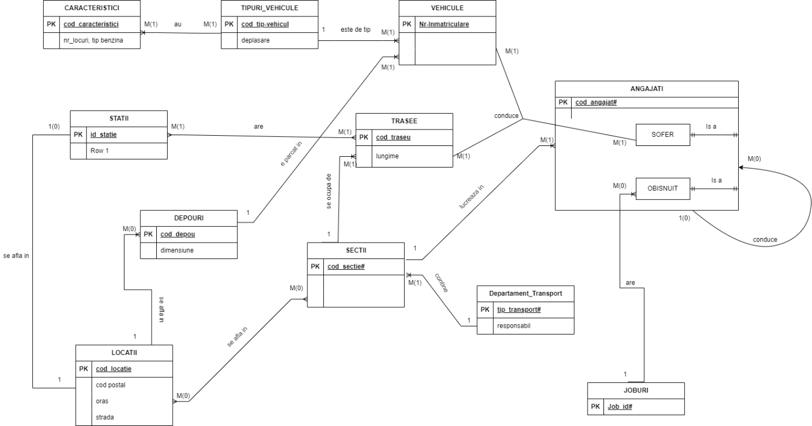

## Diagrama conceptuala

**Pornind de la diagrama entitate-relație realizați diagrama conceptuală a modelului propus, integrând toate atributele necesare: entitățile, relațiile și atributele trebuie definite în limba română.**

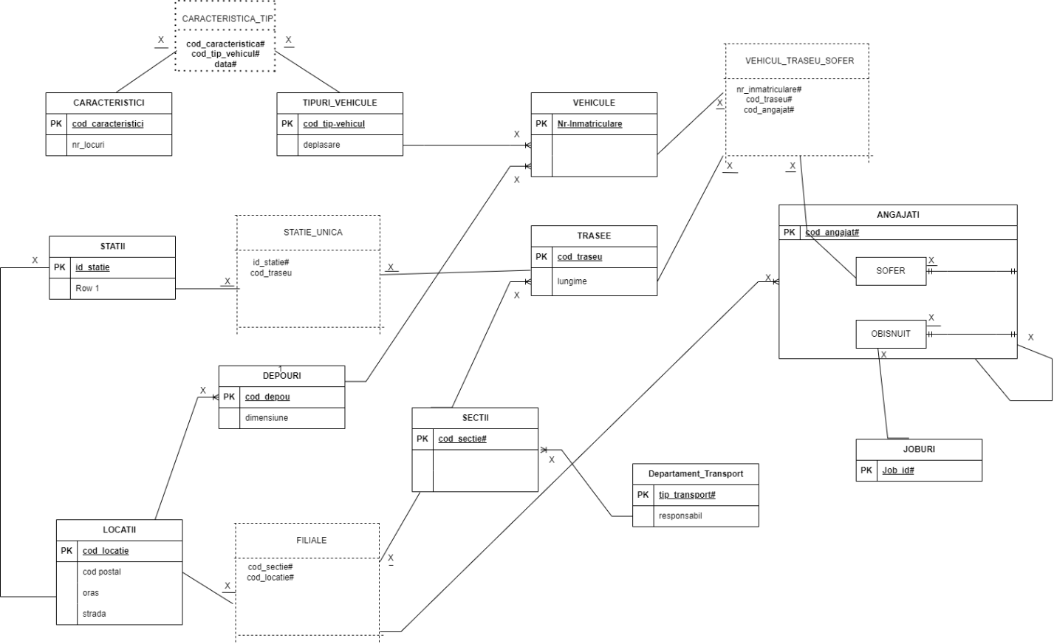

## 4. CREATE

**Implementați în Oracle diagrama conceptuală realizată: definiți toate tabelele, definind toate constrângerile de integritate necesare (chei primare, cheile externe etc).**

|  |
| --- |
| CREATE TABLE angajati_stc(  cod_angajat VARCHAR2(25) primary key,  nume VARCHAR(25) CONSTRAINT nume_vid NOT NULL,  data_angajare DATE default sysdate,  salariu NUMBER(10) default 2500  );  CREATE TABLE joburi(  cod_job VARCHAR2(25) primary key,  nume VARCHAR(25) CONSTRAINT numeJob_vid NOT NULL,  ore_pe_zi NUMBER(2)  );  CREATE TABLE obisnuit_stc(  cod_angajat VARCHAR2(25) primary key references angajati_stc(cod_angajat),  cod_job VARCHAR2(25),  constraint codJob_fk foreign key(cod_job) references joburi (cod_job)  );  CREATE TABLE sofer_stc(  cod_angajat VARCHAR2(25) primary key references angajati_stc(cod_angajat),  tip_permis VARCHAR2(25) constraint permis_conducere NOT NULL  );  ALTER TABLE angajati_stc  ADD (cod_sef VARCHAR2(25) REFERENCES angajati_stc(cod_angajat));  desc angajati_stc;  ALTER TABLE sofer_stc  MODIFY tip_permis default 'z-profesionist';  CREATE TABLE departament_transport_stc(  tip_transport VARCHAR2(25) primary key,  responsabil VARCHAR2(25) references angajati_stc(cod_angajat)  );  ALTER TABLE departament_transport_stc  ADD (nume_departament VARCHAR(25) NOT NULL);  CREATE TABLE sectii_stc(  cod_sectie VARCHAR2(25) primary key,  responsabil VARCHAR2(25) references angajati_stc(cod_angajat),  tip_transport VARCHAR2(25) references departament_transport_stc(tip_transport)  );  ALTER TABLE sectii_stc  ADD (nume_sectie VARCHAR(25));  CREATE TABLE locatii_stc(  cod_locatie VARCHAR2(25) primary key,  nume VARCHAR(25) CONSTRAINT numeLoc_vid UNIQUE,  adresa VARCHAR(25) UNIQUE,  cod_postal NUMBER(7)  );  CREATE TABLE filiale_stc(  cod_sectie VARCHAR2(25) references sectii_stc(cod_sectie),  cod_locatie VARCHAR2(25) references locatii_stc(cod_locatie),  responsabil VARCHAR2(25) references angajati_stc(cod_angajat),  primary key (cod_sectie, cod_locatie)  );  ALTER TABLE angajati_stc  ADD (cod_sectie VARCHAR2(25),  cod_locatie VARCHAR(25),  CONSTRAINT fkey_angajati foreign key (cod_sectie, cod_locatie)  REFERENCES filiale_stc(cod_sectie,cod_locatie));  CREATE TABLE trasee_stc(  cod_traseu VARCHAR2(25) primary key,  capat1 VARCHAR(25),  capat2 VARCHAR(25),  lungime NUMBER(7),  cod_sectie VARCHAR2(25) references sectii_stc(cod_sectie)  );  CREATE TABLE depouri_stc(  cod_depou VARCHAR2(25) primary key,  nume_depou VARCHAR2(25),  capacitate NUMBER(5),  cod_locatie VARCHAR2(25) references locatii_stc(cod_locatie)  );  CREATE TABLE statii_stc(  cod_statie VARCHAR2(25) primary key,  nume_statie VARCHAR2(25),  cod_locatie VARCHAR2(25) references locatii_stc(cod_locatie)  );  CREATE TABLE statie_unica_stc(  cod_statie VARCHAR2(25) references statii_stc(cod_statie),  cod_traseu VARCHAR2(25) references trasee_stc(cod_traseu),  primary key (cod_statie, cod_traseu)  );  ALTER TABLE trasee_stc  ADD CONSTRAINT fkey_capat1 FOREIGN KEY(capat1) REFERENCES statii_stc(cod_statie);  ALTER TABLE trasee_stc  ADD CONSTRAINT fkey_capat2 FOREIGN KEY(capat2) REFERENCES statii_stc(cod_statie);  CREATE TABLE tipuri_vehicule_stc(  cod_tip_vehicul VARCHAR2(25) primary key,  nume VARCHAR2(25),  marca VARCHAR(25)  );  CREATE TABLE caracteristici_stc(  cod_caract NUMBER(3) primary key,  nr_locuri NUMBER(3),  nr_roti NUMBER(2),  combustibil NUMBER(3),  seria VARCHAR2(10),  model VARCHAR2(10),  an DATE default sysdate  );  ALTER TABLE caracteristici_stc  DROP COLUMN combustibil;  ALTER TABLE caracteristici_stc  ADD combustibil VARCHAR(25) default 'benzina';  ALTER TABLE caracteristici_stc  MODIFY model VARCHAR(25);  CREATE TABLE caracteristica_tip(  cod_caract NUMBER(3) references caracteristici_stc(cod_caract),  cod_tip_vehicul VARCHAR2(25) references tipuri_vehicule_stc(cod_tip_vehicul),  data_start DATE,  data_expirare DATE,  primary key (cod_caract, cod_tip_vehicul, data_start)  );  CREATE TABLE vehicule_stc(  nr_inmatriculare VARCHAR2(10) primary key,  cod_tip_vehicul VARCHAR2(25) references tipuri_vehicule_stc(cod_tip_vehicul)  );  ALTER TABLE vehicule_stc  ADD (cod_depou VARCHAR2(25) REFERENCES depouri_stc(cod_depou));  desc vehicule_stc;  CREATE TABLE vehicul_traseu_sofer(  cod_angajat VARCHAR2(25) references sofer_stc(cod_angajat),  nr_inmatriculare VARCHAR2(10) references vehicule_stc(nr_inmatriculare),  cod_traseu VARCHAR2(25) references trasee_stc(cod_traseu),  primary key (nr_inmatriculare, cod_traseu, cod_angajat)  ); |

## 5. INSERT

Adăugați informații coerente în tabelele create (minim 5 înregistrări pentru fiecare entitate independentă; minim 10 înregistrări pentru tabela asociativă).

|  |
| --- |
| INSERT INTO joburi  VALUES ('J0','Contabil',8);  INSERT INTO joburi  VALUES ('J1','Asistent_HR',6);  INSERT INTO joburi  VALUES ('J2','Programator',6);  INSERT INTO joburi  VALUES ('J3','Project_Manager',10);  INSERT INTO joburi  VALUES ('J4','Consultant',2);  INSERT INTO joburi  VALUES ('J5','Tehnician Securitate',5);  INSERT INTO joburi  VALUES ('J6','Mecanic auto',8);  INSERT INTO departament_transport_stc (tip_transport, nume_departament)  VALUES ('DT0','Terestru_auto');  INSERT INTO departament_transport_stc (tip_transport, nume_departament)  VALUES ('DT1','Tren');  INSERT INTO departament_transport_stc (tip_transport, nume_departament)  VALUES ('DT2','Subteran');  INSERT INTO departament_transport_stc (tip_transport, nume_departament)  VALUES ('DT3','Nautic');  INSERT INTO departament_transport_stc (tip_transport, nume_departament)  VALUES ('DT4','Aerian');  commit;  INSERT INTO sectii_stc (cod_sectie, tip_transport, nume_sectie)  VALUES ('S0', 'DT0', 'autobuz');  INSERT INTO sectii_stc (cod_sectie, tip_transport, nume_sectie)  VALUES ('S1', 'DT0', 'troleibuz');  INSERT INTO sectii_stc (cod_sectie, tip_transport, nume_sectie)  VALUES ('S2', 'DT0', 'microbuz');  INSERT INTO sectii_stc (cod_sectie, tip_transport, nume_sectie)  VALUES ('S3', 'DT1', 'tren');  INSERT INTO sectii_stc (cod_sectie, tip_transport, nume_sectie)  VALUES ('S4', 'DT1', 'tramvai');  INSERT INTO sectii_stc (cod_sectie, tip_transport, nume_sectie)  VALUES ('S5', 'DT2', 'metrou');  INSERT INTO sectii_stc (cod_sectie, tip_transport, nume_sectie)  VALUES ('S6', 'DT2', 'metrou expres');  INSERT INTO sectii_stc (cod_sectie, tip_transport, nume_sectie)  VALUES ('S7', 'DT3', 'vaporas');  INSERT INTO sectii_stc (cod_sectie, tip_transport, nume_sectie)  VALUES ('S8', 'DT3', 'barca');  INSERT INTO sectii_stc (cod_sectie, tip_transport, nume_sectie)  VALUES ('S9', 'DT3', 'gondola');  INSERT INTO sectii_stc (cod_sectie, tip_transport, nume_sectie)  VALUES ('S10', 'DT3', 'hidrobicicleta');  INSERT INTO sectii_stc (cod_sectie, tip_transport, nume_sectie)  VALUES ('S11', 'DT4', 'parapanta');  INSERT INTO sectii_stc (cod_sectie, tip_transport, nume_sectie)  VALUES ('S12', 'DT4', 'elicopter');  INSERT INTO locatii_stc  VALUES ('L0','Crangasi','Str. Ceahlaul, nr 3', '060371');  INSERT INTO locatii_stc  VALUES ('L1','Serban','Calea Serban Voda, nr 288', '040223');  INSERT INTO locatii_stc  VALUES ('L2','Manolescu','Str. Manolescu Grig, nr 2', '011234');  INSERT INTO locatii_stc  VALUES ('L3','Herastrau','Blv. Regele Mihai I', '015449');  INSERT INTO locatii_stc  VALUES ('L4','Vianu','Str. Arh. Ion Mincu', '018772');  INSERT INTO locatii_stc  VALUES ('L5','Gara de Nord','Blv. Dinicu Golescu', '060388');  INSERT INTO locatii_stc  VALUES ('L6','Dambovita','Splaiul Independentei', '025466');  INSERT INTO locatii_stc  VALUES ('L7','Aeroport Baneasa','Sos. Bucuresti-Ploiesti', '012211');  INSERT INTO locatii_stc  VALUES ('L8','Pantelimon','Str. Campului, nr 99', '039928');  INSERT INTO locatii_stc  VALUES ('L9','Aparatorii Patriei','Str. Dumitru Dumitru', '0552134');  INSERT INTO locatii_stc  VALUES ('L10','Parcul Sebastian','Calea 13 Septembrie, nr 4', '059912');  INSERT INTO depouri_stc  VALUES ('D0','Crangasi',302,'L0');  INSERT INTO depouri_stc  VALUES ('D1','Parcul Sebastian',700,'L10');  INSERT INTO depouri_stc  VALUES ('D2','Gara de nord',50,'L5');  INSERT INTO depouri_stc  VALUES ('D3','Herastrau',147,'L3');  INSERT INTO depouri_stc  VALUES ('D4','Aeroport Baneasa',45,'L7');  commit;  INSERT INTO statii_stc  VALUES ('St0','Crangasi','L0');  INSERT INTO statii_stc  VALUES ('St1','Serban','L1');  INSERT INTO statii_stc  VALUES ('St2','Manolescu','L2');  INSERT INTO statii_stc  VALUES ('St3','Herastrau','L3');  INSERT INTO statii_stc  VALUES ('St4','Vianu','L4');  INSERT INTO statii_stc  VALUES ('St5','Gara de Nord','L5');  INSERT INTO statii_stc  VALUES ('St6','Dambovita','L6');  INSERT INTO statii_stc  VALUES ('St7','Aeroport Baneasa','L7');  INSERT INTO trasee_stc  VALUES ('T0','St0','St7', 13, 'S0');  INSERT INTO trasee_stc  VALUES ('T1','St5','St7', 10, 'S2');  INSERT INTO trasee_stc  VALUES ('T2','St4','St3', 4, 'S4');  INSERT INTO trasee_stc  VALUES ('T3','St3','St6', 15, 'S7');  INSERT INTO trasee_stc  VALUES ('T4','St1','St2', 25, 'S6');  INSERT INTO trasee_stc  VALUES ('T5','St1','St7', 20, 'S12');  INSERT INTO filiale_stc (cod_sectie, cod_locatie)  VALUES ('S0','L0');  INSERT INTO filiale_stc (cod_sectie, cod_locatie)  VALUES ('S0','L1');  INSERT INTO filiale_stc (cod_sectie, cod_locatie)  VALUES ('S1','L3');  INSERT INTO filiale_stc (cod_sectie, cod_locatie)  VALUES ('S1','L5');  INSERT INTO filiale_stc (cod_sectie, cod_locatie)  VALUES ('S1','L6');  INSERT INTO filiale_stc (cod_sectie, cod_locatie)  VALUES ('S2','L8');  INSERT INTO filiale_stc (cod_sectie, cod_locatie)  VALUES ('S2','L9');  INSERT INTO filiale_stc (cod_sectie, cod_locatie)  VALUES ('S10','L10');  INSERT INTO filiale_stc (cod_sectie, cod_locatie)  VALUES ('S10','L7');  INSERT INTO filiale_stc (cod_sectie, cod_locatie)  VALUES ('S8','L4');  INSERT INTO filiale_stc (cod_sectie, cod_locatie)  VALUES ('S8','L8');  commit;  INSERT INTO statie_unica_stc  VALUES ('St0','T1');  INSERT INTO statie_unica_stc  VALUES ('St0','T0');  INSERT INTO statie_unica_stc  VALUES ('St1','T0');  INSERT INTO statie_unica_stc  VALUES ('St1','T1');  INSERT INTO statie_unica_stc  VALUES ('St2','T4');  INSERT INTO statie_unica_stc  VALUES ('St2','T3');  INSERT INTO statie_unica_stc  VALUES ('St2','T5');  INSERT INTO statie_unica_stc  VALUES ('St3','T3');  INSERT INTO statie_unica_stc  VALUES ('St4','T3');  INSERT INTO statie_unica_stc  VALUES ('St5','T1');  INSERT INTO statie_unica_stc  VALUES ('St6','T0');  commit;  INSERT INTO caracteristici_stc (cod_caract, nr_locuri, nr_roti, seria, model, an)  VALUES (100,40,4,'rx33','infinitybus',TO_DATE('17/dec/2015', 'DD/MON/YYYY'));  INSERT INTO caracteristici_stc (cod_caract, nr_locuri, nr_roti, seria, model, an)  VALUES (101,45,4,'rx34','infinitybus2',TO_DATE('17/dec/2023', 'DD/MON/YYYY'));  INSERT INTO caracteristici_stc (cod_caract, nr_locuri, nr_roti, seria, model, an)  VALUES (102,20,4,'qqq0','legendtrolley',TO_DATE('12/mar/2005', 'DD/MON/YYYY'));  INSERT INTO caracteristici_stc (cod_caract, nr_locuri, nr_roti, seria, model, an, combustibil)  VALUES (103,3,0,'5005','hydra',TO_DATE('1/jan/2010', 'DD/MON/YYYY'), 'fara');  INSERT INTO caracteristici_stc (cod_caract, nr_locuri, nr_roti, seria, model, an, combustibil)  VALUES (104,6,0,'po21','hydra',TO_DATE('17/aug/2008', 'DD/MON/YYYY'), 'fara');  INSERT INTO caracteristici_stc (cod_caract, nr_locuri, nr_roti, seria, model, an,combustibil)  VALUES (105,4,3,'aero','eagleland',TO_DATE('28/may/2020', 'DD/MON/YYYY'), 'diesel');  INSERT INTO caracteristici_stc (cod_caract, nr_locuri, nr_roti, seria, model, an,combustibil)  VALUES (106,50,16,'rr41','railmonster',TO_DATE('2/may/2001', 'DD/MON/YYYY'), 'electric');  INSERT INTO caracteristici_stc (cod_caract, nr_locuri, nr_roti, seria, model, an,combustibil)  VALUES (107,50,16,'rr4i1','railmonster',TO_DATE('2/may/2001', 'DD/MON/YYYY'), 'electric');  INSERT INTO tipuri_vehicule_stc  VALUES('TV0','autobuz','bus2000');  INSERT INTO tipuri_vehicule_stc  VALUES('TV1','troleibuz','bus2000');  INSERT INTO tipuri_vehicule_stc  VALUES('TV2','tramvai','rail++');  INSERT INTO tipuri_vehicule_stc  VALUES('TV3','caiac','hidrofun');  INSERT INTO tipuri_vehicule_stc  VALUES('TV4','barca','hidrofun');  INSERT INTO tipuri_vehicule_stc  VALUES('TV5','elicopter','The Bold Eagle');  INSERT INTO tipuri_vehicule_stc  VALUES('TV6','tren','rail++');  INSERT INTO tipuri_vehicule_stc  VALUES('TV7','metrou','rail++');  INSERT INTO tipuri_vehicule_stc  VALUES('TV8','microbuz','bus2000');  INSERT INTO caracteristica_tip  VALUES (100,'TV0',TO_DATE('17/dec/2015', 'DD/MON/YYYY'),TO_DATE('16/dec/2023', 'DD/MON/YYYY'));  INSERT INTO caracteristica_tip (cod_caract, cod_tip_vehicul, data_start)  VALUES (101,'TV0',TO_DATE('17/dec/2023', 'DD/MON/YYYY'));  INSERT INTO caracteristica_tip  VALUES (107,'TV7',TO_DATE('2/may/2001', 'DD/MON/YYYY'),TO_DATE('2/may/2003', 'DD/MON/YYYY'));  INSERT INTO caracteristica_tip  VALUES (106,'TV7',TO_DATE('3/may/2003', 'DD/MON/YYYY'),TO_DATE('1/may/2005', 'DD/MON/YYYY'));  INSERT INTO caracteristica_tip  VALUES (107,'TV7',TO_DATE('2/may/2005', 'DD/MON/YYYY'),TO_DATE('2/may/2009', 'DD/MON/YYYY'));  INSERT INTO caracteristica_tip(cod_caract, cod_tip_vehicul, data_start)  VALUES (107,'TV6',TO_DATE('3/may/2001', 'DD/MON/YYYY'));  INSERT INTO caracteristica_tip(cod_caract, cod_tip_vehicul, data_start)  VALUES (102,'TV1',TO_DATE('12/mar/2005', 'DD/MON/YYYY'));  INSERT INTO caracteristica_tip(cod_caract, cod_tip_vehicul, data_start)  VALUES (107,'TV2',TO_DATE('3/may/2001', 'DD/MON/YYYY'));  INSERT INTO caracteristica_tip(cod_caract, cod_tip_vehicul, data_start)  VALUES (103,'TV3',TO_DATE('1/jan/2010', 'DD/MON/YYYY'));  INSERT INTO caracteristica_tip(cod_caract, cod_tip_vehicul, data_start)  VALUES (104,'TV4',TO_DATE('17/aug/2008', 'DD/MON/YYYY'));  INSERT INTO caracteristica_tip(cod_caract, cod_tip_vehicul, data_start)  VALUES (105,'TV5',TO_DATE('28/may/2020', 'DD/MON/YYYY'));  INSERT INTO caracteristica_tip(cod_caract, cod_tip_vehicul, data_start)  VALUES (100,'TV8',TO_DATE('17/dec/2015', 'DD/MON/YYYY'));  INSERT INTO vehicule_stc  VALUES ('B-45-BUS','TV0','D0');  INSERT INTO vehicule_stc  VALUES ('B-46-BUS','TV0','D0');  INSERT INTO vehicule_stc  VALUES ('B-03-TRO','TV1','D0');  INSERT INTO vehicule_stc  VALUES ('B-04-TRO','TV1','D0');  INSERT INTO vehicule_stc  VALUES ('B-41-RAM','TV2','D1');  INSERT INTO vehicule_stc  VALUES ('B-11-RAM','TV2','D1');  INSERT INTO vehicule_stc  VALUES ('B-00-CAY','TV3','D3');  INSERT INTO vehicule_stc  VALUES ('B-01-CAY','TV3','D3');  INSERT INTO vehicule_stc  VALUES ('B-02-CAY','TV3','D3');  INSERT INTO vehicule_stc  VALUES ('B-04-CAY','TV3','D3');  INSERT INTO vehicule_stc  VALUES ('B-00-BAR','TV4','D3');  INSERT INTO vehicule_stc  VALUES ('B-01-BAR','TV4','D3');  INSERT INTO vehicule_stc  VALUES ('B-0-HELL','TV5','D4');  INSERT INTO vehicule_stc  VALUES ('B-1-HELL','TV5','D4');  INSERT INTO vehicule_stc  VALUES ('B-3-HELL','TV5','D4');  INSERT INTO vehicule_stc  VALUES ('B-99-REN','TV6','D2');  INSERT INTO vehicule_stc  VALUES ('B-97-REN','TV6','D2');  INSERT INTO vehicule_stc  VALUES ('B-92-REN','TV6','D2');  INSERT INTO vehicule_stc  VALUES ('B-30-MTR','TV7','D2');  INSERT INTO vehicule_stc  VALUES ('B-31-MTR','TV7','D2');  INSERT INTO vehicule_stc  VALUES ('B-66-MIC','TV8','D0');  COMMIT;  desc angajati_stc;  INSERT INTO angajati_stc (cod_angajat,nume,data_angajare,salariu, cod_sectie)  VALUES ('A0','Augustus',to_date('12/dec/1990','dd/mon/yyyy'), 10000,'S0');  INSERT INTO angajati_stc (cod_angajat,nume,data_angajare,salariu, cod_sectie)  VALUES ('A1','Bartolomeu',to_date('12/dec/1990','dd/mon/yyyy'), 10000,'S1');  INSERT INTO angajati_stc (cod_angajat,nume,data_angajare,salariu, cod_sectie)  VALUES ('A2','Cicero',to_date('12/dec/1990','dd/mon/yyyy'), 10000,'S2');  INSERT INTO angajati_stc (cod_angajat,nume,data_angajare,salariu, cod_sectie)  VALUES ('A3','Dionys',to_date('12/dec/1990','dd/mon/yyyy'), 10000,'S3');  INSERT INTO angajati_stc (cod_angajat,nume,data_angajare,salariu, cod_sectie)  VALUES ('A4','Elena',to_date('12/dec/1990','dd/mon/yyyy'), 10000,'S4');  INSERT INTO angajati_stc (cod_angajat,nume,data_angajare,salariu, cod_sectie)  VALUES ('A5','Faust',to_date('12/dec/1990','dd/mon/yyyy'), 10000,'S5');  INSERT INTO angajati_stc (cod_angajat,nume,data_angajare,salariu, cod_sectie)  VALUES ('A6','Gregorio',to_date('12/dec/1990','dd/mon/yyyy'), 10000,'S6');  INSERT INTO angajati_stc (cod_angajat,nume,data_angajare,salariu, cod_sectie)  VALUES ('A7','Heracle',to_date('12/dec/1990','dd/mon/yyyy'), 10000,'S7');  INSERT INTO angajati_stc (cod_angajat,nume,data_angajare,salariu, cod_sectie)  VALUES ('A8','Iulius',to_date('12/dec/1990','dd/mon/yyyy'), 10000,'S8');  INSERT INTO angajati_stc (cod_angajat,nume,data_angajare,salariu, cod_sectie)  VALUES ('A9','Juna',to_date('12/dec/1990','dd/mon/yyyy'), 10000,'S9');  INSERT INTO angajati_stc (cod_angajat,nume,data_angajare,salariu, cod_sectie)  VALUES ('A10','Klaus',to_date('12/dec/1990','dd/mon/yyyy'), 10000,'S10');  INSERT INTO angajati_stc (cod_angajat,nume,data_angajare,salariu, cod_sectie)  VALUES ('A11','Lucretia',to_date('12/dec/1990','dd/mon/yyyy'), 10000,'S11');  INSERT INTO angajati_stc (cod_angajat,nume,data_angajare,salariu, cod_sectie)  VALUES ('A12','Manolo',to_date('12/dec/1990','dd/mon/yyyy'), 10000,'S12');  INSERT INTO angajati_stc (cod_angajat,nume,data_angajare,salariu, cod_sef, cod_sectie)  VALUES ('A13','Nero',to_date('12/dec/1995','dd/mon/yyyy'), 8000,'A0','S0');  INSERT INTO angajati_stc (cod_angajat,nume,data_angajare,salariu, cod_sef, cod_sectie)  VALUES ('A14','Ophelia',to_date('12/dec/1995','dd/mon/yyyy'), 8000,'A1','S1');  INSERT INTO angajati_stc (cod_angajat,nume,data_angajare,salariu, cod_sef, cod_sectie)  VALUES ('A15','Patrocle',to_date('12/dec/1995','dd/mon/yyyy'), 8000,'A2','S2');  INSERT INTO angajati_stc (cod_angajat,nume,data_angajare,salariu, cod_sef, cod_sectie)  VALUES ('A16','Quince',to_date('12/dec/1995','dd/mon/yyyy'), 8000,'A3','S3');  INSERT INTO angajati_stc (cod_angajat,nume,data_angajare,salariu, cod_sef, cod_sectie)  VALUES ('A17','Ruth',to_date('12/dec/1995','dd/mon/yyyy'), 8000,'A4','S4');  INSERT INTO angajati_stc (cod_angajat,nume,data_angajare,salariu, cod_sef, cod_sectie)  VALUES ('A18','Santos',to_date('12/dec/1995','dd/mon/yyyy'), 8000,'A5','S5');  INSERT INTO angajati_stc (cod_angajat,nume,data_angajare,salariu, cod_sef, cod_sectie)  VALUES ('A19','Tremaine',to_date('12/dec/1995','dd/mon/yyyy'), 8000,'A6','S6');  INSERT INTO angajati_stc (cod_angajat,nume,data_angajare,salariu, cod_sef, cod_sectie)  VALUES ('A20','Ulise',to_date('12/dec/1995','dd/mon/yyyy'), 8000,'A7','S7');  INSERT INTO angajati_stc (cod_angajat,nume,data_angajare,salariu, cod_sef, cod_sectie)  VALUES ('A21','Venetia',to_date('12/dec/1995','dd/mon/yyyy'), 8000,'A8','S8');  INSERT INTO angajati_stc (cod_angajat,nume,data_angajare,salariu, cod_sef, cod_sectie)  VALUES ('A22','Waldo',to_date('12/dec/1995','dd/mon/yyyy'), 8000,'A9','S9');  INSERT INTO angajati_stc (cod_angajat,nume,data_angajare,salariu, cod_sef, cod_sectie)  VALUES ('A23','Xenia',to_date('12/dec/1995','dd/mon/yyyy'), 8000,'A10','S10');  INSERT INTO angajati_stc (cod_angajat,nume,data_angajare,salariu, cod_sef, cod_sectie)  VALUES ('A24','Yuri',to_date('12/dec/1995','dd/mon/yyyy'), 8000,'A11','S11');  INSERT INTO angajati_stc (cod_angajat,nume,data_angajare,salariu, cod_sef, cod_sectie)  VALUES ('A25','Zenobia',to_date('12/dec/1995','dd/mon/yyyy'), 8000,'A12','S12');  commit;  UPDATE angajati_stc  SET cod_sectie = 'S0', cod_locatie= 'L0'  where cod_angajat='A0';  UPDATE angajati_stc  SET cod_sectie = 'S1', cod_locatie= 'L3'  where cod_angajat='A1';  UPDATE angajati_stc  SET cod_sectie = 'S2', cod_locatie= 'L8'  where cod_angajat='A2';  UPDATE angajati_stc  SET cod_sectie = 'S3'  where cod_angajat='A3';  UPDATE angajati_stc  SET cod_sectie = 'S4'  where cod_angajat='A4';  UPDATE angajati_stc  SET cod_sectie = 'S5'  where cod_angajat='A5';  UPDATE angajati_stc  SET cod_sectie = 'S6'  where cod_angajat='A6';  UPDATE angajati_stc  SET cod_sectie = 'S7'  where cod_angajat='A7';  UPDATE angajati_stc  SET cod_sectie = 'S8', cod_locatie= 'L4'  where cod_angajat='A8';  UPDATE angajati_stc  SET cod_sectie = 'S9'  where cod_angajat='A9';  UPDATE angajati_stc  SET cod_sectie = 'S10', cod_locatie= 'L10'  where cod_angajat='A10';  UPDATE angajati_stc  SET cod_sectie = 'S11'  where cod_angajat='A11';  UPDATE angajati_stc  SET cod_sectie = 'S12'  where cod_angajat='A12';  UPDATE angajati_stc  SET cod_sectie = 'S0', cod_locatie= 'L1'  where cod_angajat='A13';  UPDATE angajati_stc  SET cod_sectie = 'S1', cod_locatie= 'L6'  where cod_angajat='A14';  UPDATE angajati_stc  SET cod_sectie = 'S2', cod_locatie= 'L9'  where cod_angajat='A15';  UPDATE angajati_stc  SET cod_sectie = 'S3'  where cod_angajat='A16';  UPDATE angajati_stc  SET cod_sectie = 'S4'  where cod_angajat='A17';  UPDATE angajati_stc  SET cod_sectie = 'S5'  where cod_angajat='A18';  UPDATE angajati_stc  SET cod_sectie = 'S6'  where cod_angajat='A19';  UPDATE angajati_stc  SET cod_sectie = 'S7'  where cod_angajat='A20';  UPDATE angajati_stc  SET cod_sectie = 'S8', cod_locatie= 'L8'  where cod_angajat='A21';  UPDATE angajati_stc  SET cod_sectie = 'S9'  where cod_angajat='A22';  UPDATE angajati_stc  SET cod_sectie = 'S10', cod_locatie= 'L7'  where cod_angajat='A23';  UPDATE angajati_stc  SET cod_sectie = 'S11'  where cod_angajat='A24';  UPDATE angajati_stc  SET cod_sectie = 'S12'  where cod_angajat='A25';  UPDATE angajati_stc  SET cod_sectie = 'S13'  where cod_angajat='A26';  commit;  UPDATE sectii_stc  SET responsabil='A0'  where cod_sectie='S0';  UPDATE sectii_stc  SET responsabil='A1'  where cod_sectie='S1';  UPDATE sectii_stc  SET responsabil='A2'  where cod_sectie='S2';  UPDATE sectii_stc  SET responsabil='A3'  where cod_sectie='S3';  UPDATE sectii_stc  SET responsabil='A4'  where cod_sectie='S4';  UPDATE sectii_stc  SET responsabil='A5'  where cod_sectie='S5';  UPDATE sectii_stc  SET responsabil='A6'  where cod_sectie='S6';  UPDATE sectii_stc  SET responsabil='A7'  where cod_sectie='S7';  UPDATE sectii_stc  SET responsabil='A8'  where cod_sectie='S8';  UPDATE sectii_stc  SET responsabil='A9'  where cod_sectie='S9';  UPDATE sectii_stc  SET responsabil='A10'  where cod_sectie='S10';  UPDATE sectii_stc  SET responsabil='A11'  where cod_sectie='S11';  UPDATE sectii_stc  SET responsabil='A12'  where cod_sectie='S12';  UPDATE departament_transport_stc  SET responsabil='A0'  WHERE tip_transport='DT0';  UPDATE departament_transport_stc  SET responsabil='A3'  WHERE tip_transport='DT1';  UPDATE departament_transport_stc  SET responsabil='A6'  WHERE tip_transport='DT2';  UPDATE departament_transport_stc  SET responsabil='A9'  WHERE tip_transport='DT3';  UPDATE departament_transport_stc  SET responsabil='A12'  WHERE tip_transport='DT4';  commit;  UPDATE angajati_stc a  set cod_sef = (select d.responsabil  from departament_transport_stc d join sectii_stc s on(d.tip_transport=s.tip_transport)  where s.cod_sectie=a.cod_sectie and cod_angajat!=d.responsabil)  where salariu>8000;  UPDATE filiale_stc f  set responsabil = (select responsabil  from sectii_stc  where cod_sectie= f.cod_sectie);  commit;  INSERT INTO obisnuit_stc  VALUES ('A0','J3');  INSERT INTO obisnuit_stc  VALUES ('A1','J1');  INSERT INTO obisnuit_stc  VALUES ('A2','J2');  INSERT INTO obisnuit_stc  VALUES ('A3','J3');  INSERT INTO obisnuit_stc  VALUES ('A4','J1');  INSERT INTO obisnuit_stc  VALUES ('A5','J5');  INSERT INTO obisnuit_stc  VALUES ('A6','J3');  INSERT INTO obisnuit_stc  VALUES ('A7','J6');  INSERT INTO obisnuit_stc  VALUES ('A8','J1');  INSERT INTO obisnuit_stc  VALUES ('A9','J3');  INSERT INTO obisnuit_stc  VALUES ('A10','J4');  INSERT INTO obisnuit_stc  VALUES ('A11','J0');  INSERT INTO obisnuit_stc  VALUES ('A12','J3');  INSERT INTO sofer_stc (cod_angajat)  SELECT cod_angajat  from angajati_stc  WHERE salariu=8000  ;  INSERT INTO vehicul_traseu_sofer  VALUES ('A13','B-45-BUS','T0');  INSERT INTO vehicul_traseu_sofer  VALUES ('A13','B-46-BUS','T0');  INSERT INTO vehicul_traseu_sofer  VALUES ('A14','B-04-TRO','T0');  INSERT INTO vehicul_traseu_sofer  VALUES ('A14','B-04-TRO','T5');  INSERT INTO vehicul_traseu_sofer  VALUES ('A15','B-66-MIC','T3');  INSERT INTO vehicul_traseu_sofer  VALUES ('A16','B-99-REN','T4');  INSERT INTO vehicul_traseu_sofer  VALUES ('A16','B-99-REN','T3');  INSERT INTO vehicul_traseu_sofer  VALUES ('A16','B-92-REN','T1');  INSERT INTO vehicul_traseu_sofer  VALUES ('A16','B-97-REN','T4');  INSERT INTO vehicul_traseu_sofer  VALUES ('A17','B-41-RAM','T0');  INSERT INTO vehicul_traseu_sofer  VALUES ('A18','B-30-MTR','T2');  INSERT INTO vehicul_traseu_sofer  VALUES ('A19','B-31-MTR','T2');  INSERT INTO vehicul_traseu_sofer  VALUES ('A19','B-30-MTR','T2');  INSERT INTO vehicul_traseu_sofer  VALUES ('A20','B-00-BAR','T4');  INSERT INTO vehicul_traseu_sofer  VALUES ('A21','B-01-BAR','T4');  INSERT INTO vehicul_traseu_sofer  VALUES ('A22','B-00-CAY','T2');  INSERT INTO vehicul_traseu_sofer  VALUES ('A23','B-00-CAY','T2');  INSERT INTO vehicul_traseu_sofer  VALUES ('A23','B-04-CAY','T2');  INSERT INTO vehicul_traseu_sofer  VALUES ('A24','B-0-HELL','T5');  INSERT INTO vehicul_traseu_sofer  VALUES ('A25','B-1-HELL','T5');  INSERT INTO vehicul_traseu_sofer  VALUES ('A25','B-3-HELL','T3');  commit; |

1. Departament transport

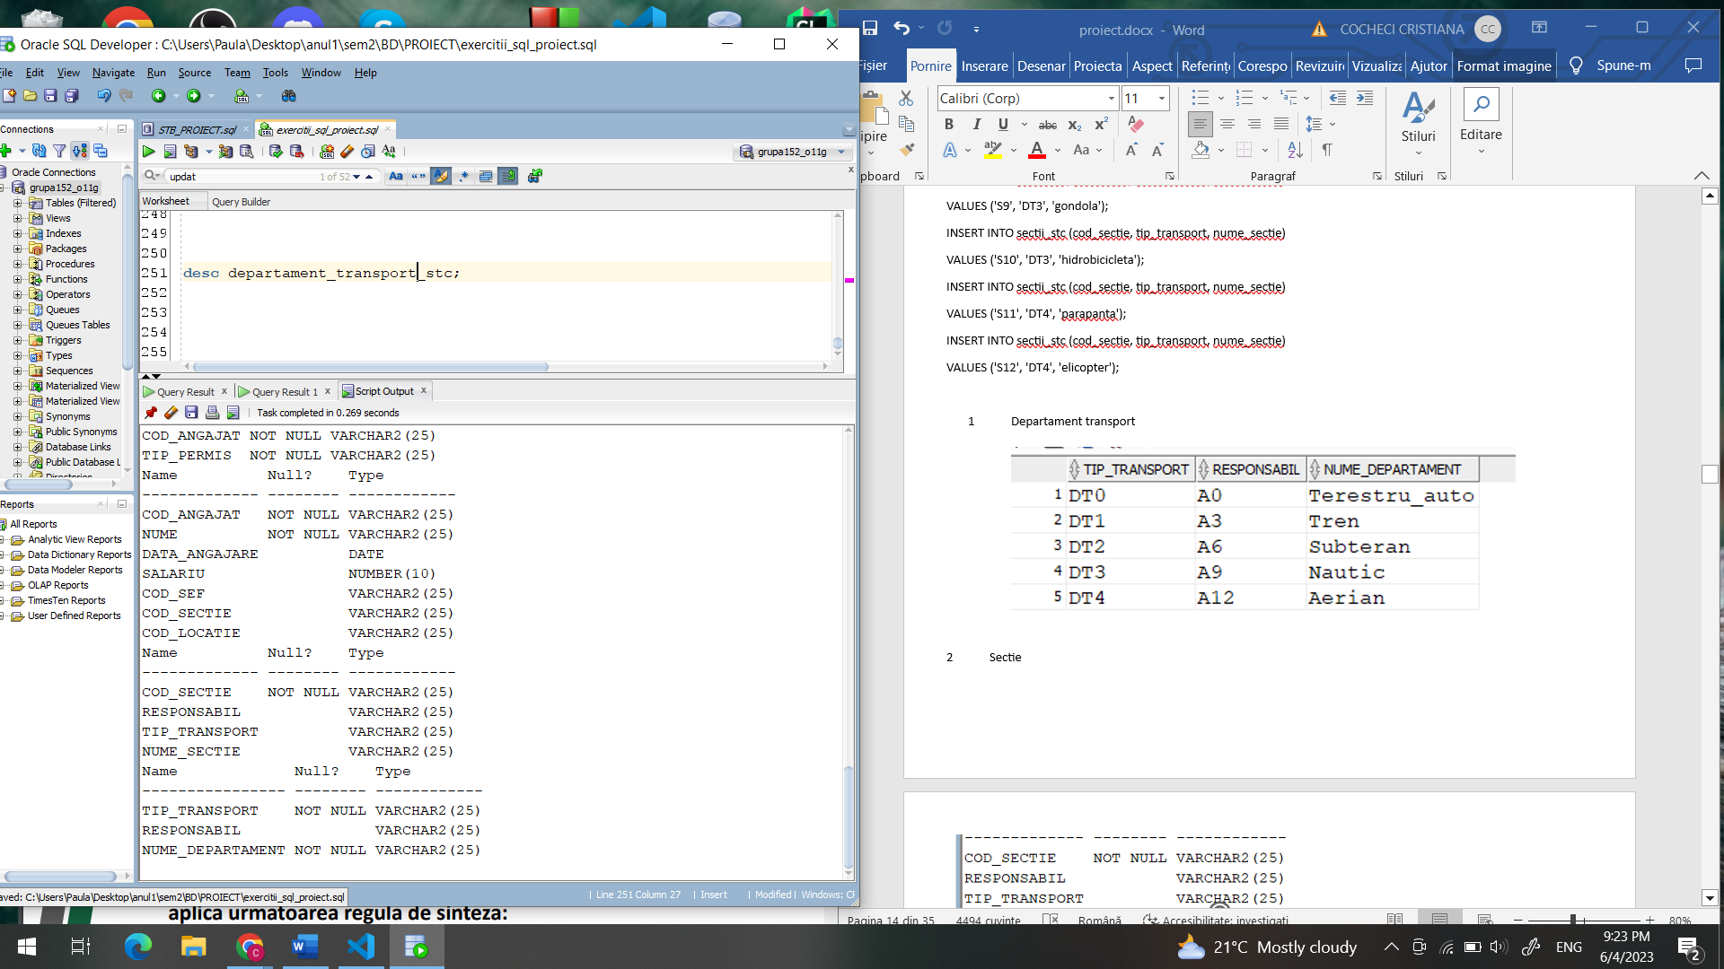

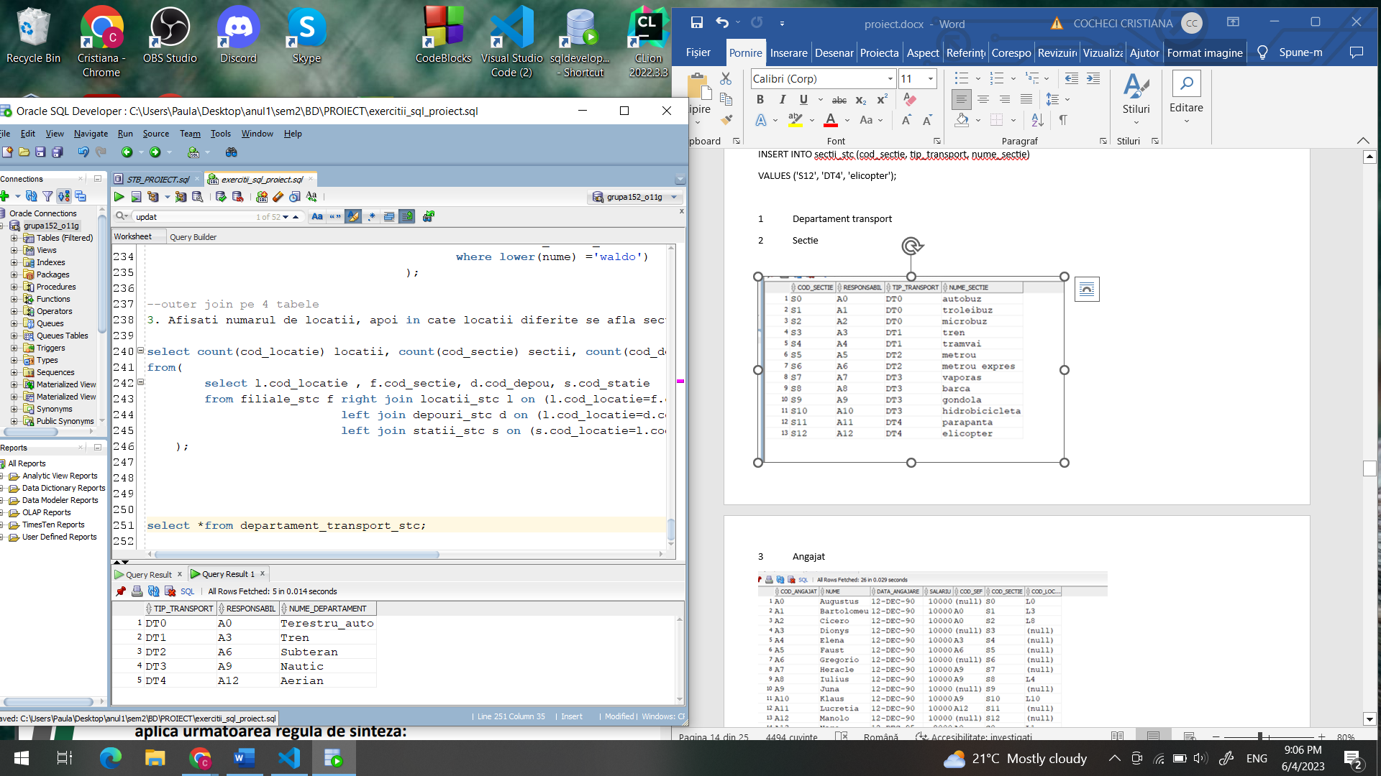

2 Sectie

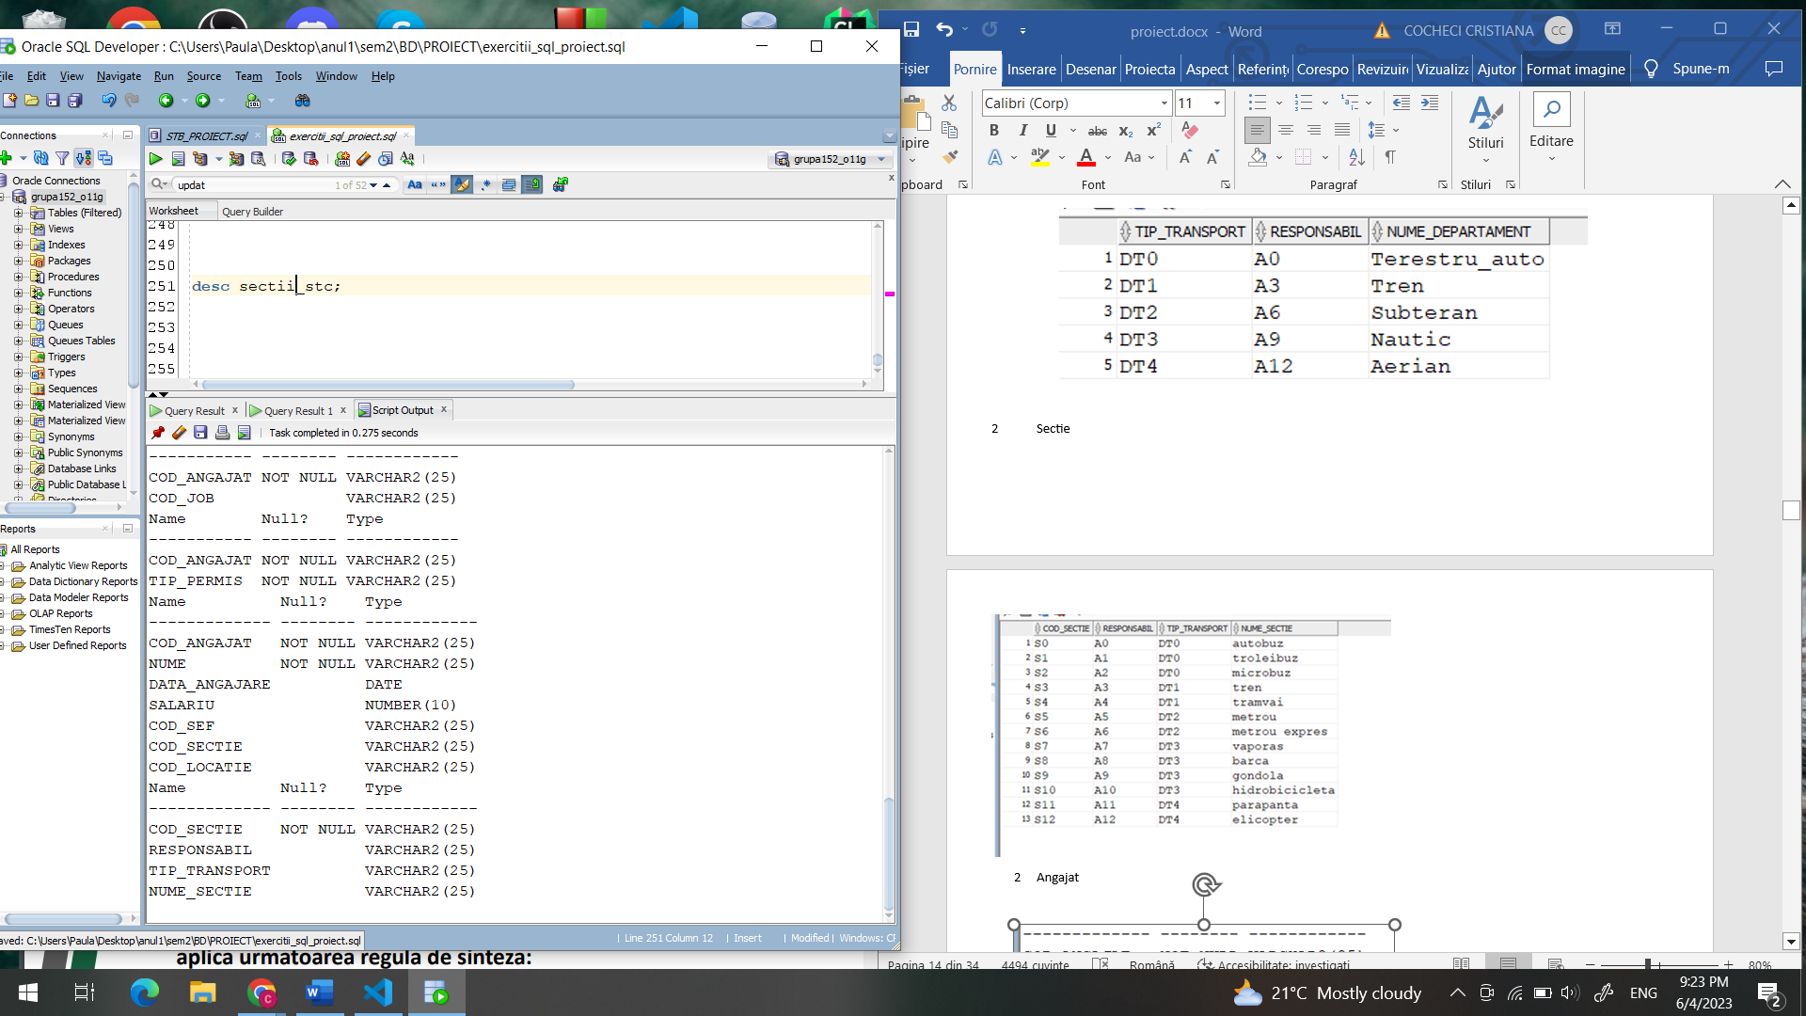

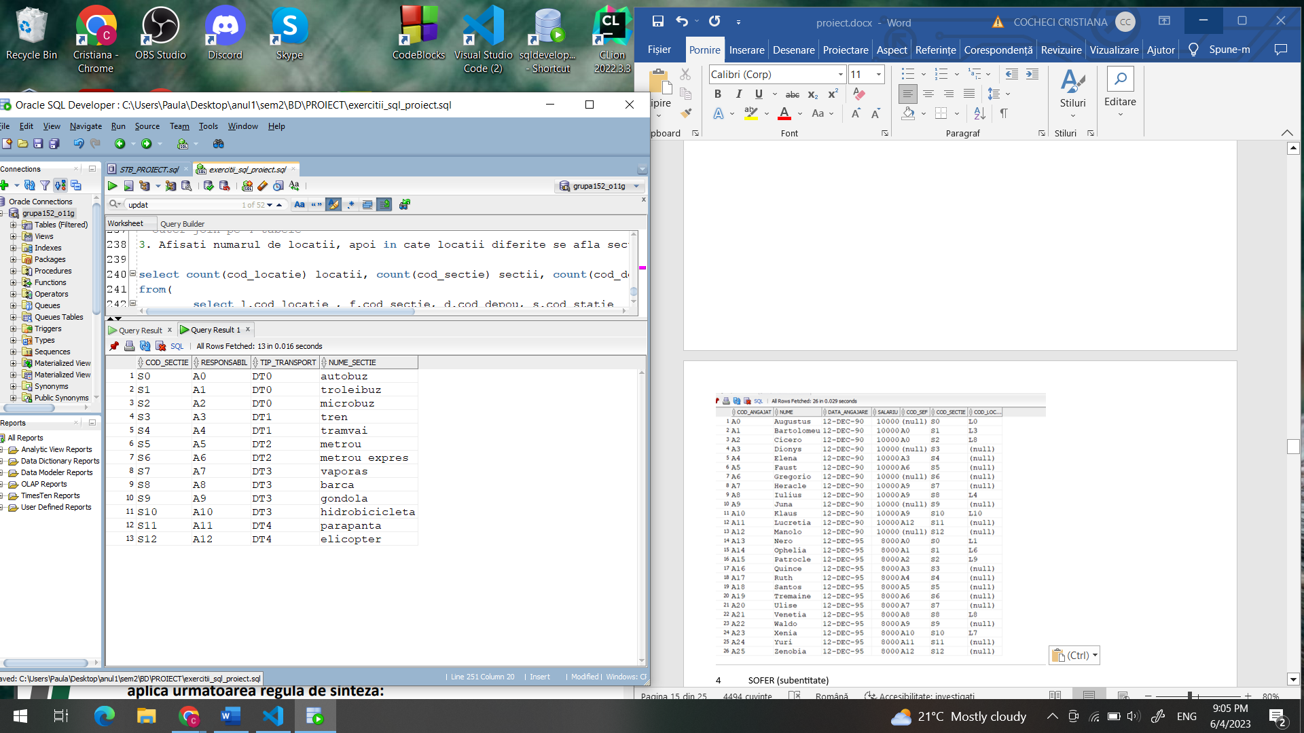

1. Angajat

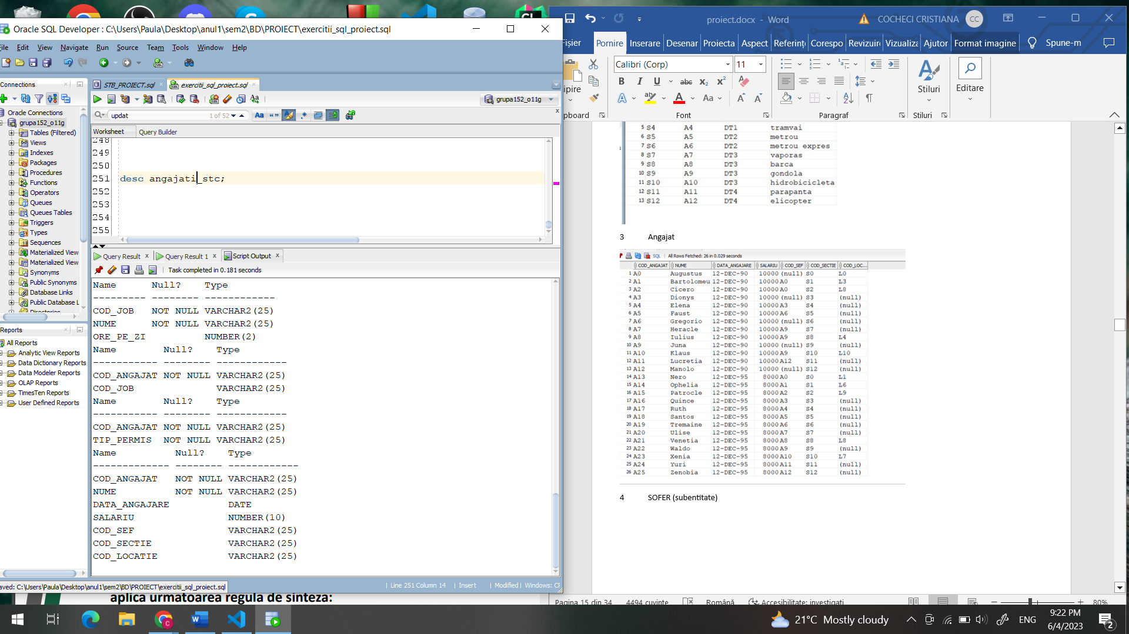

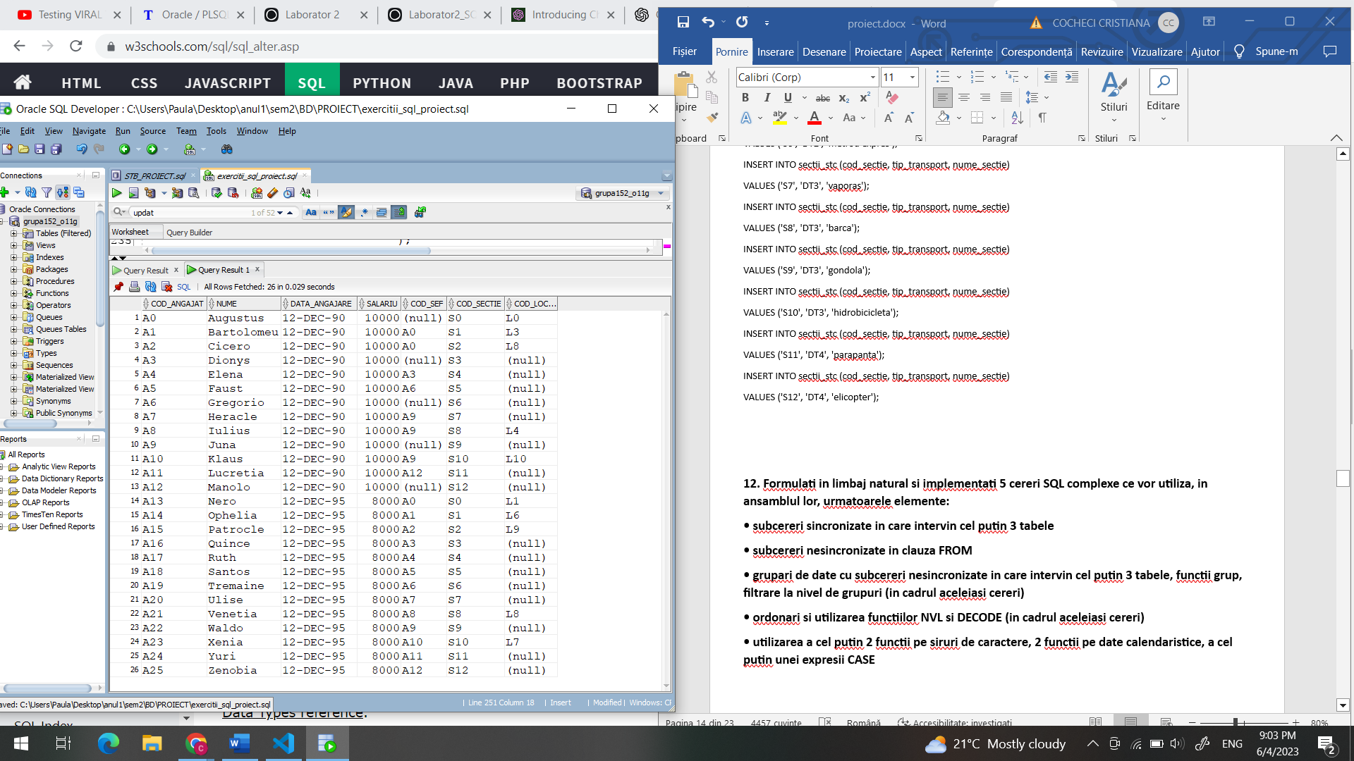

4 SOFER (subentitate)

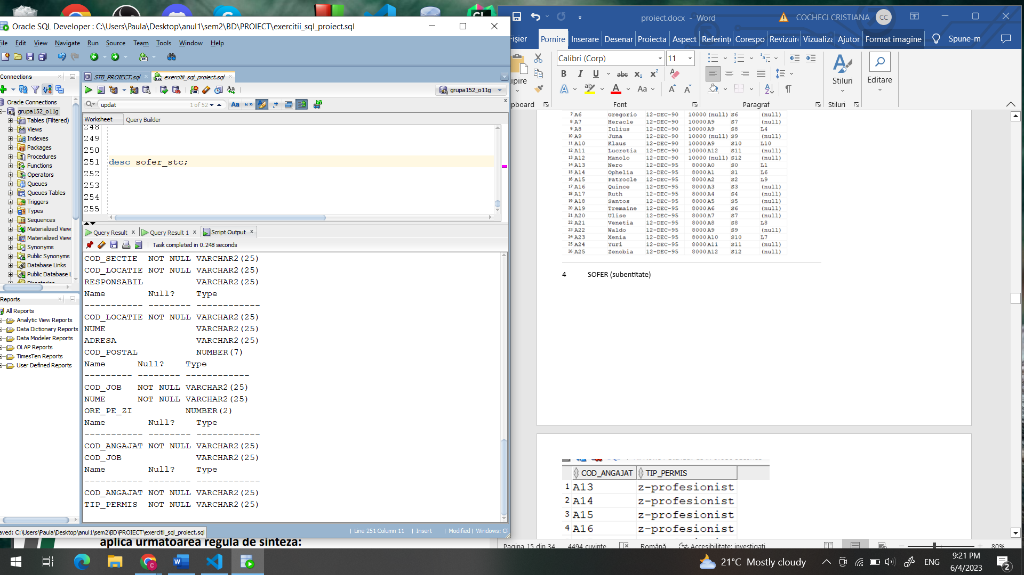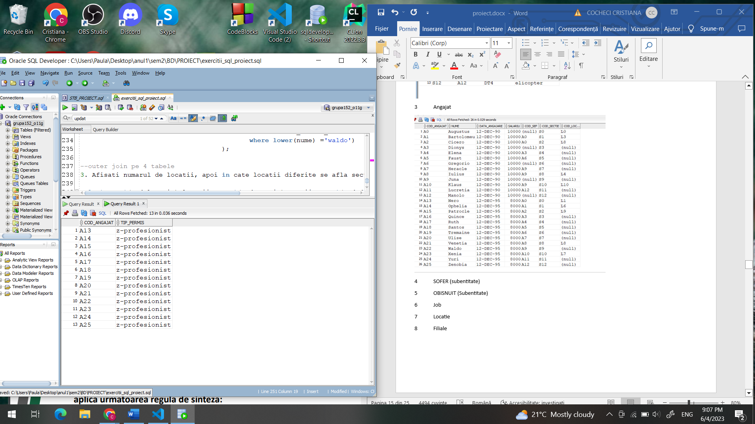

5 OBISNUIT (Subentitate)

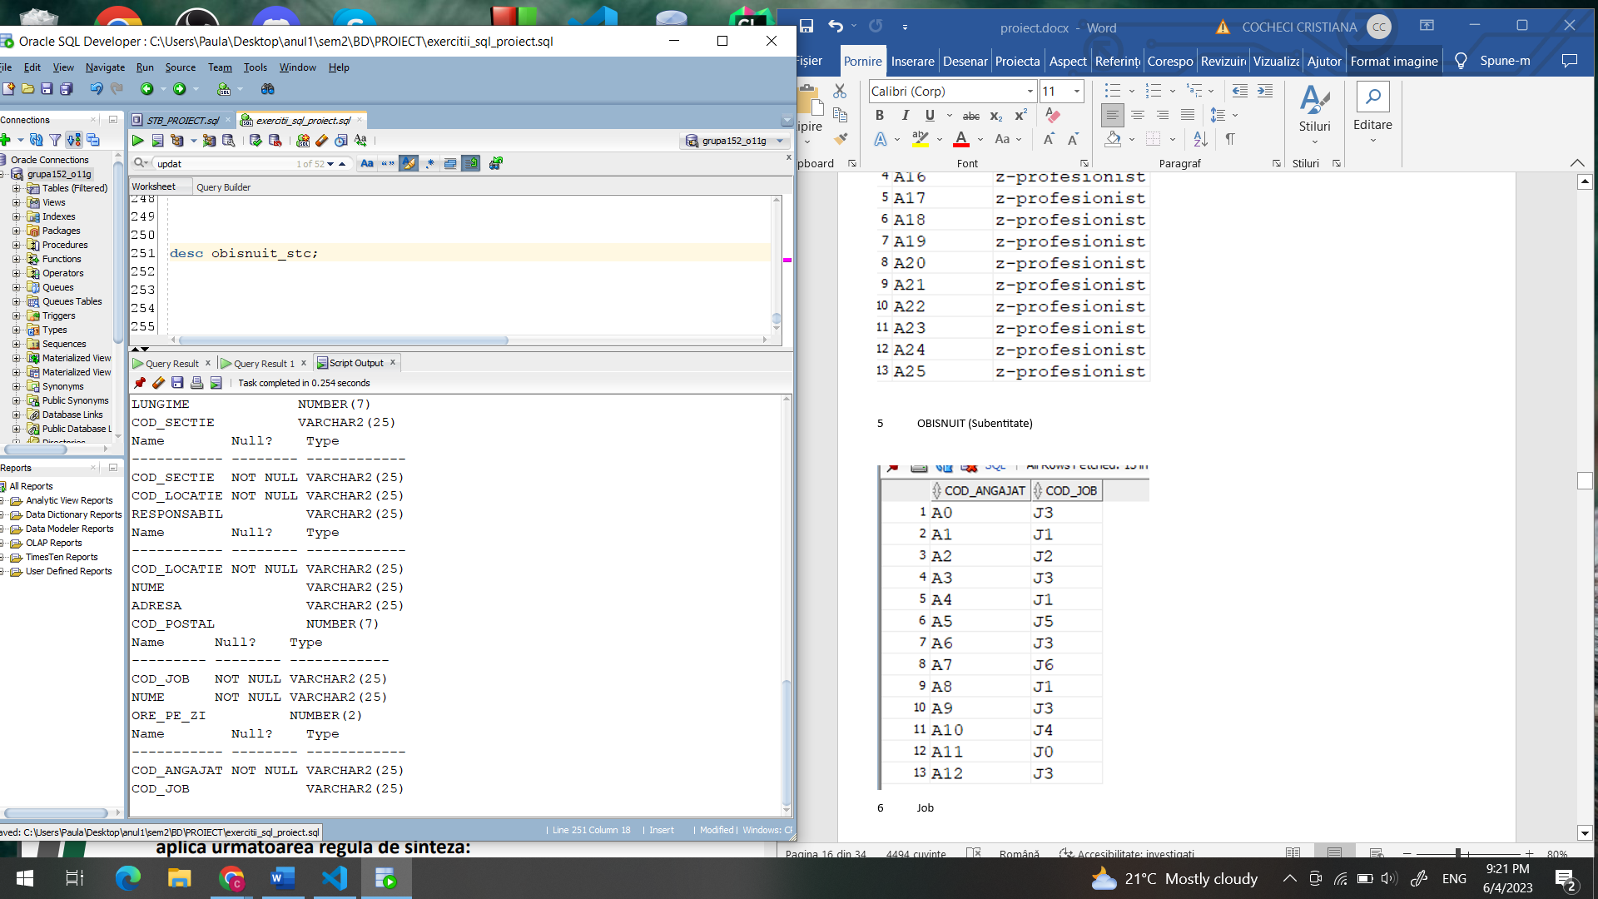

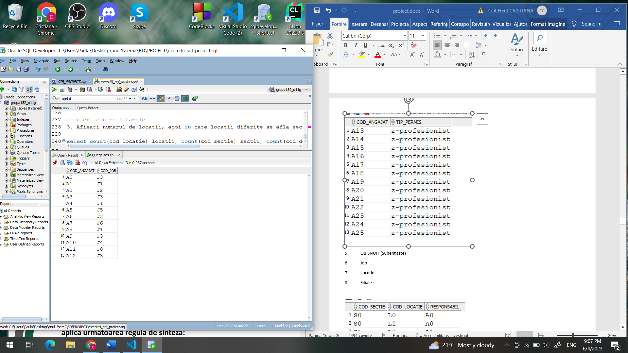

6 Job

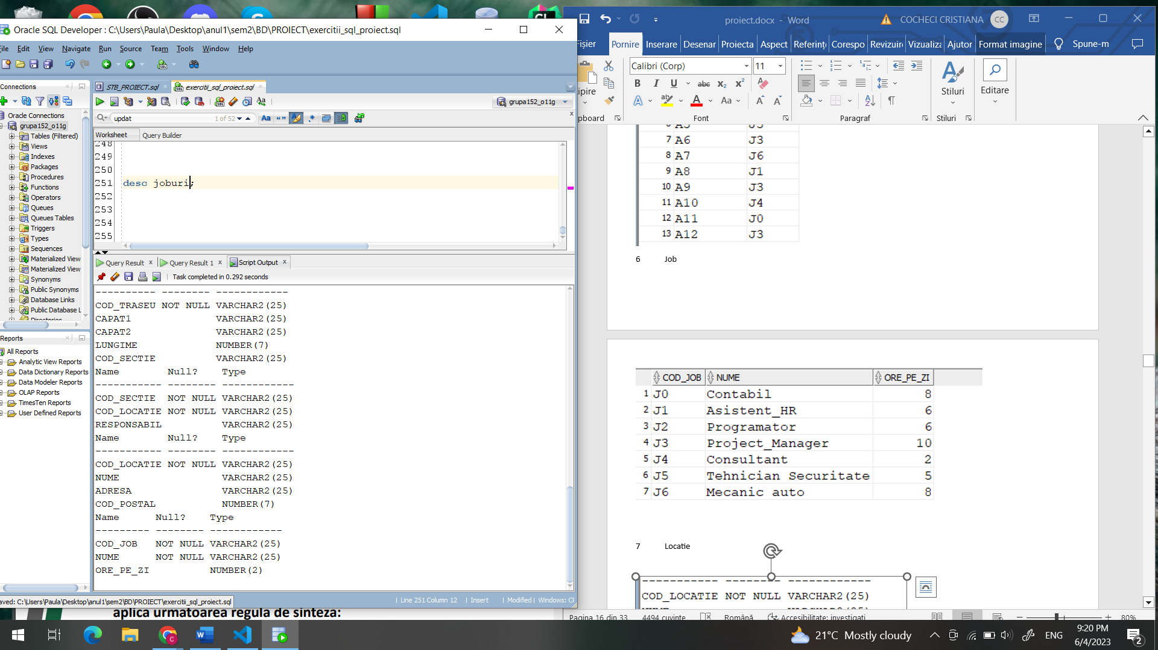

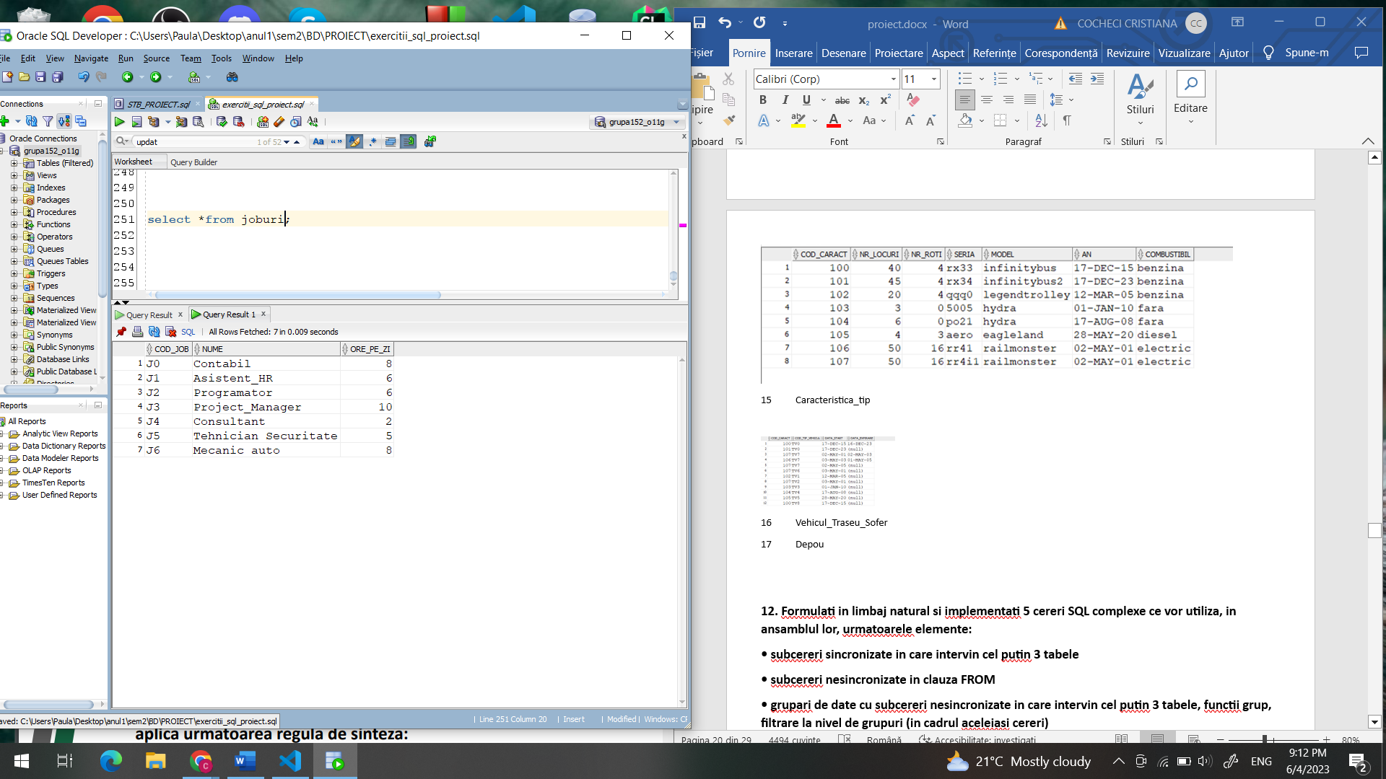

7 Locatie

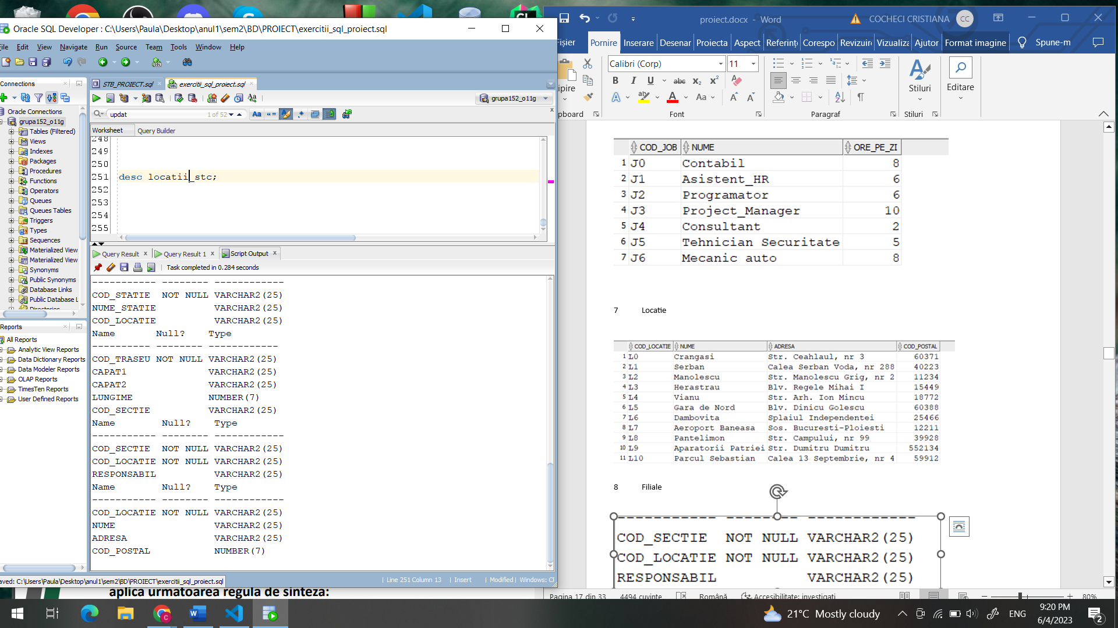

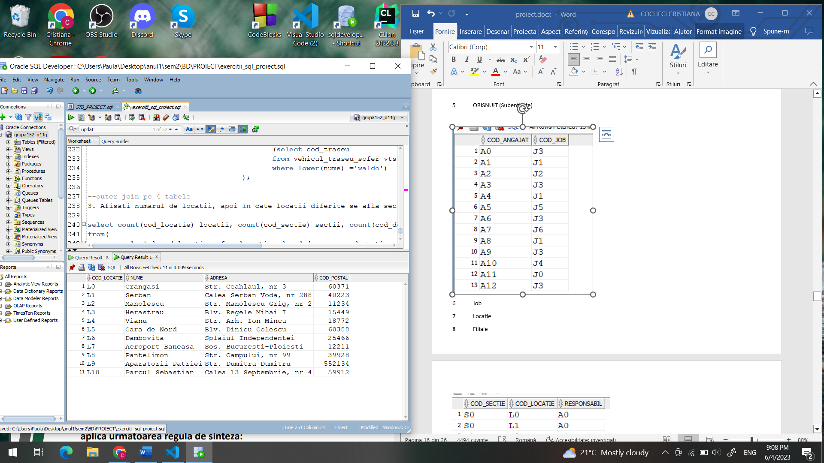

8 Filiale

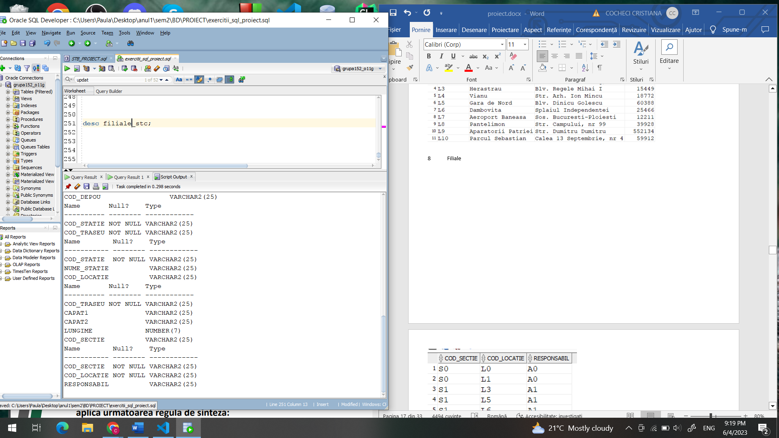

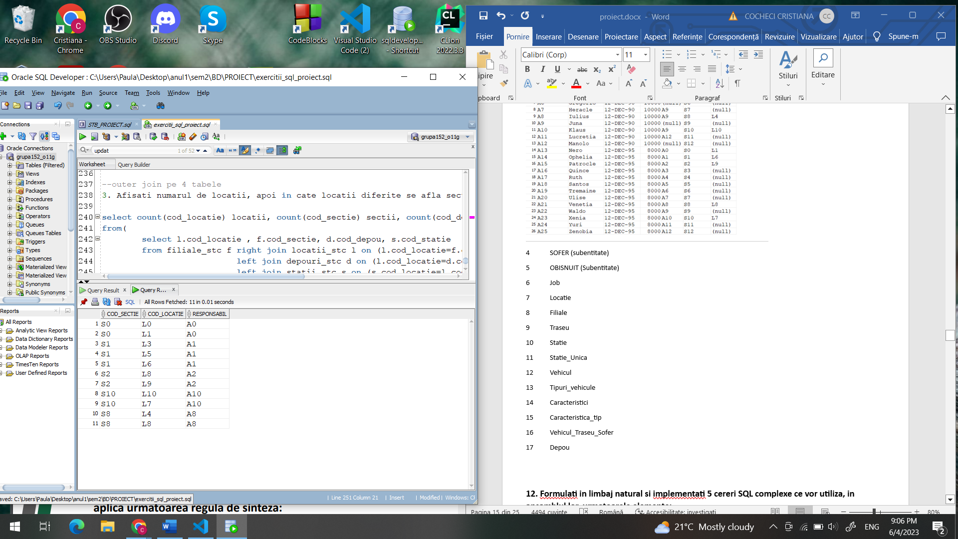

9 Traseu

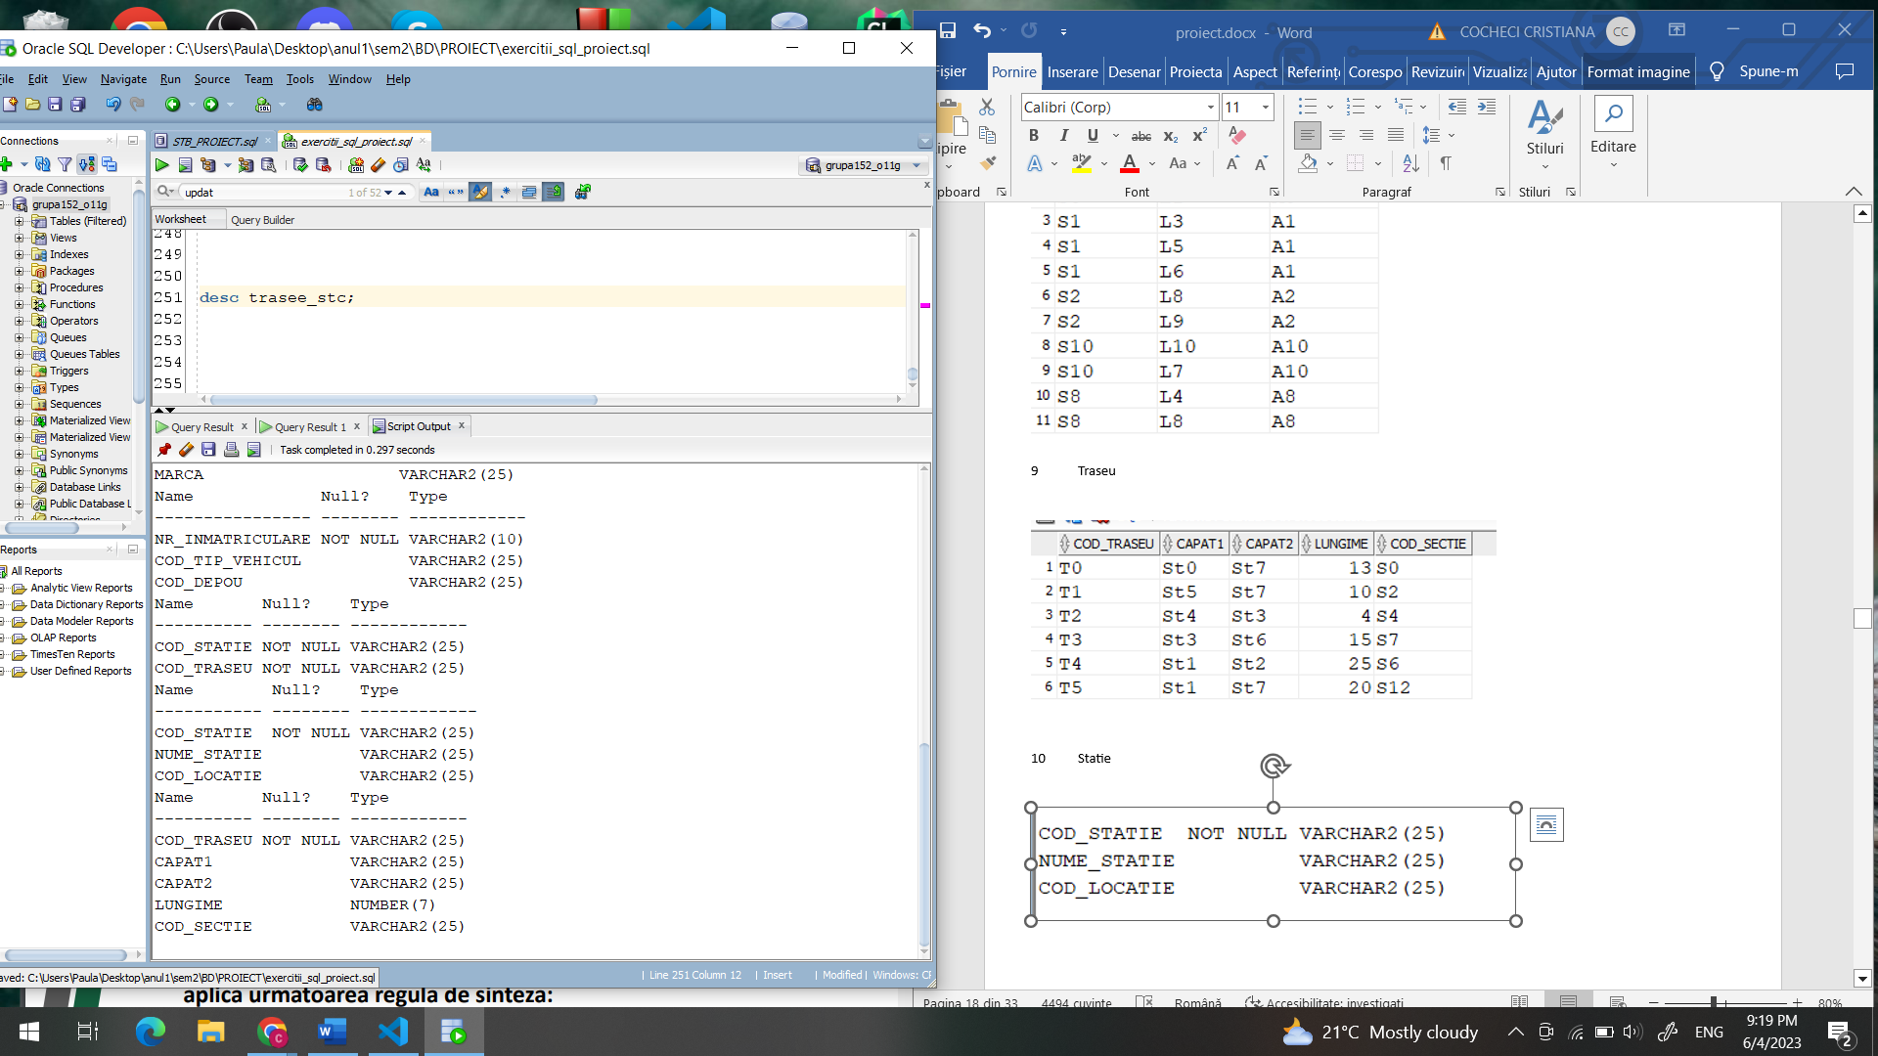

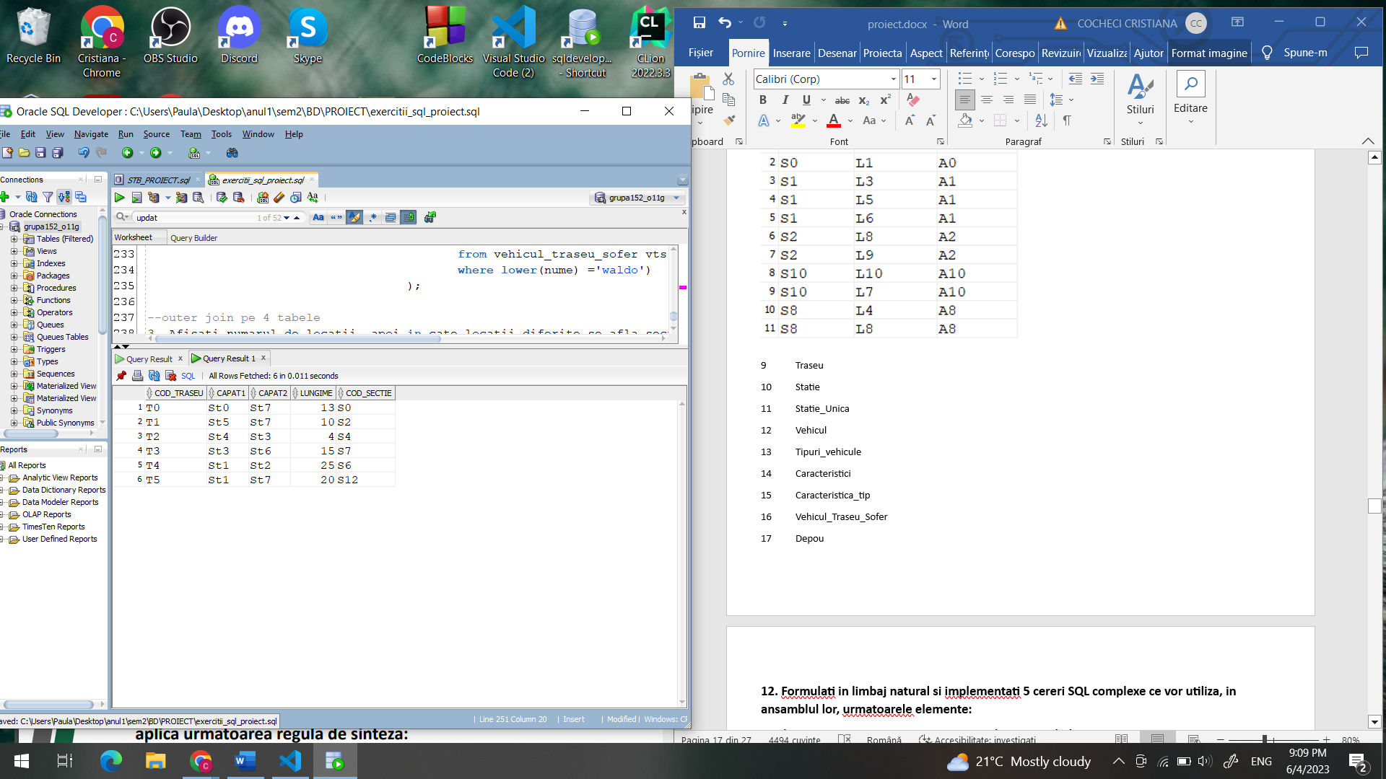

10 Statie

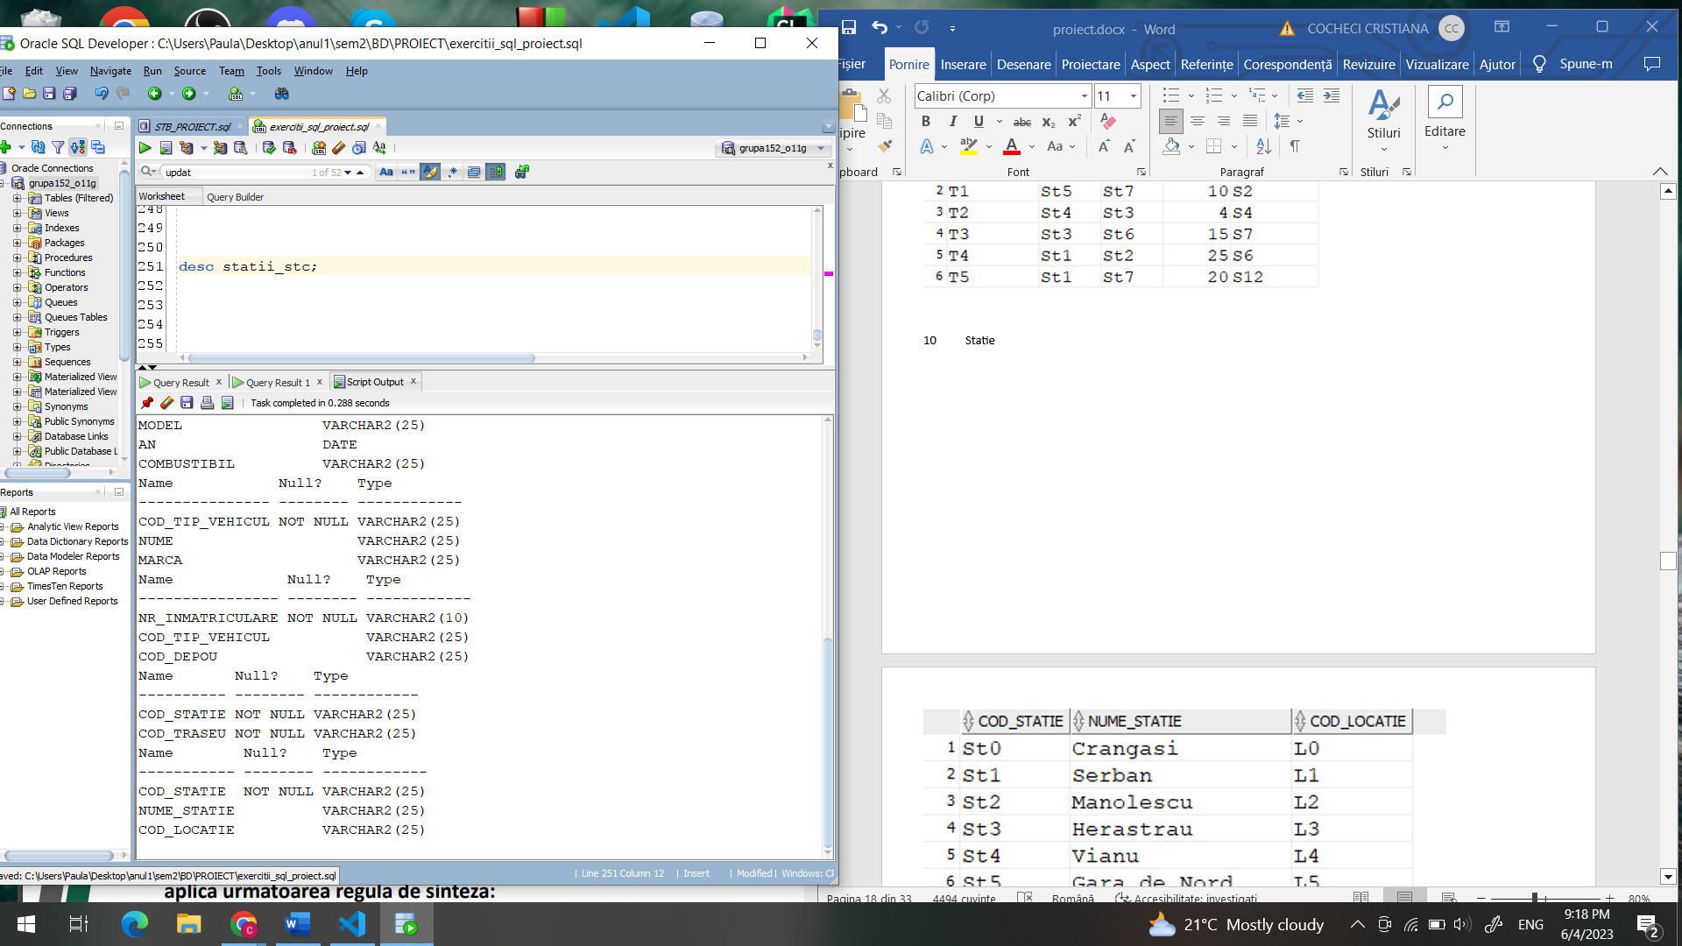

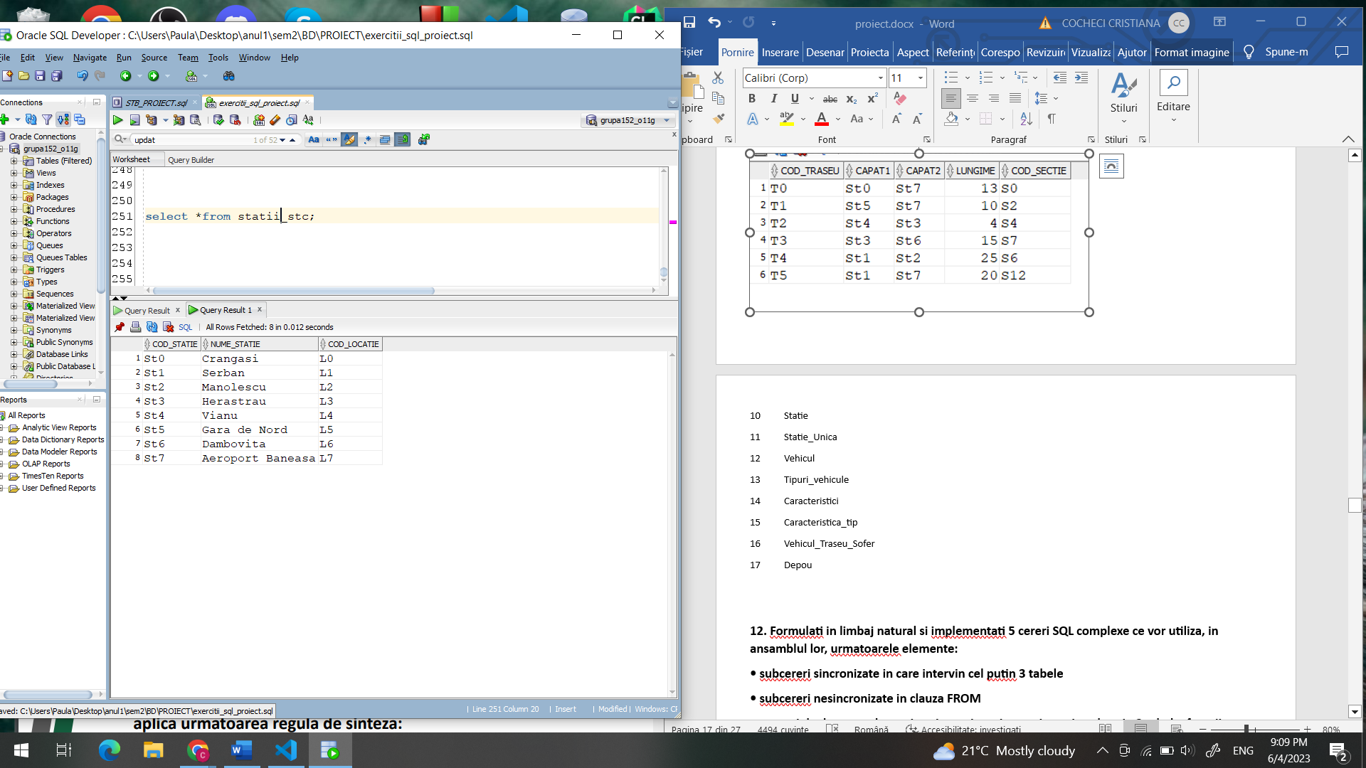

11 Statie_Unica

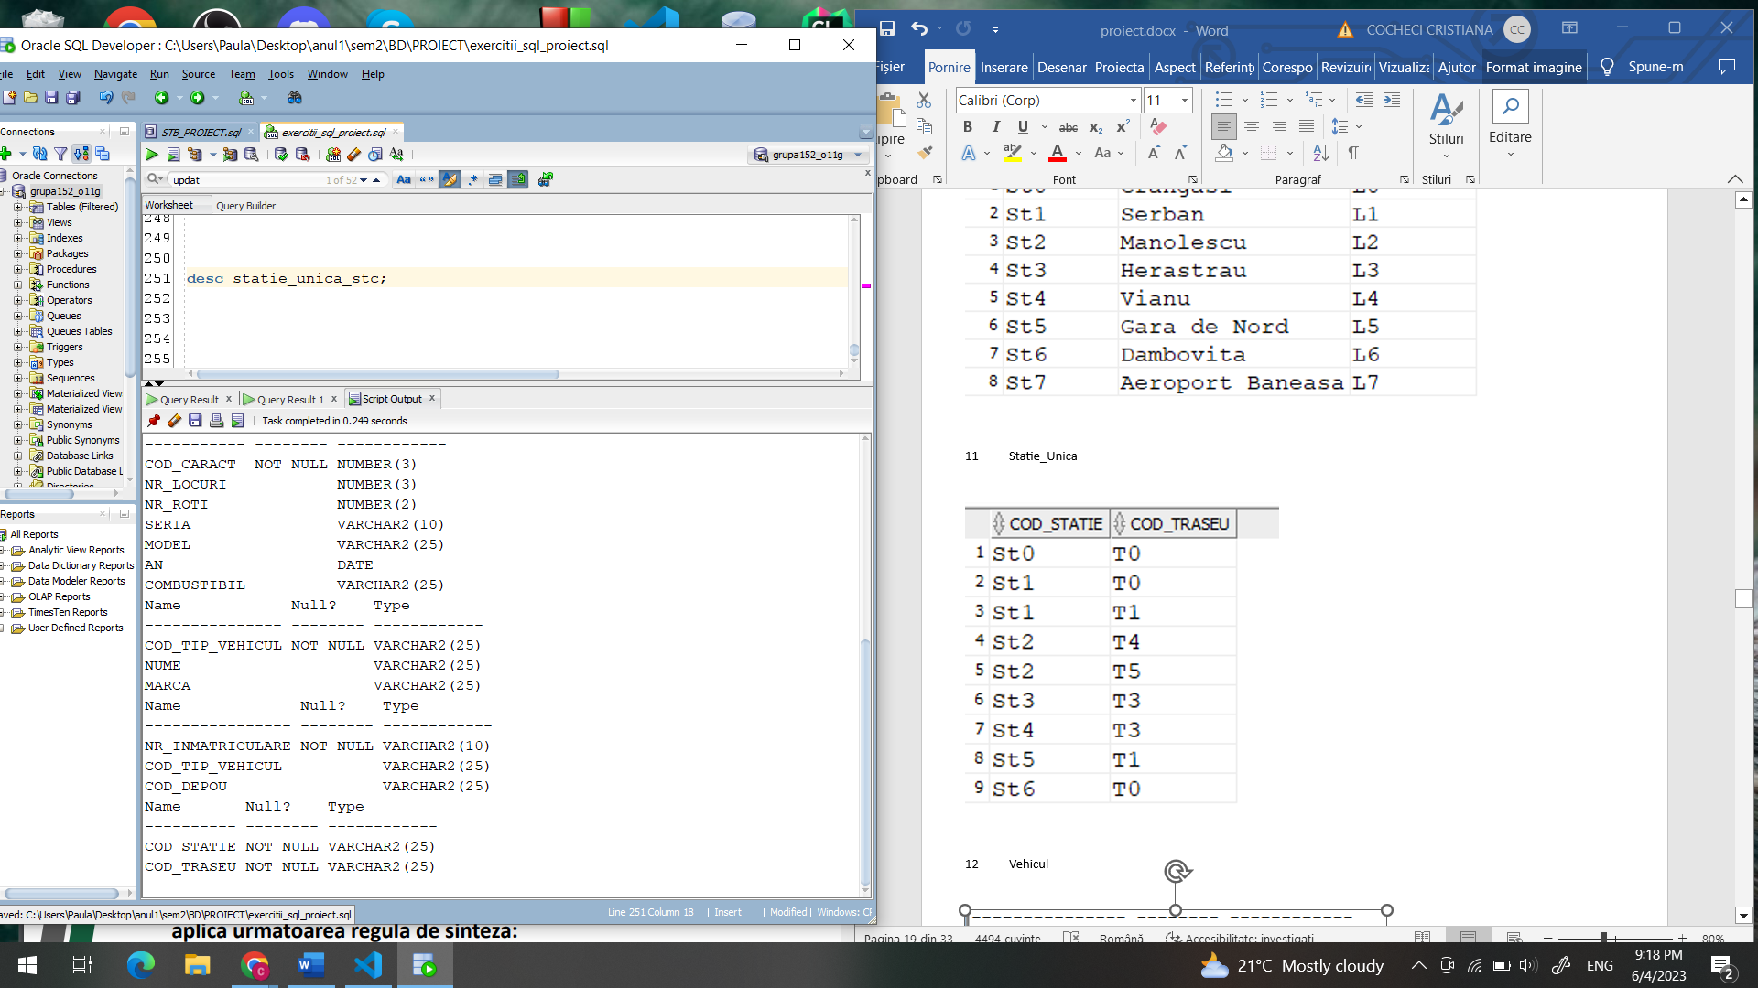

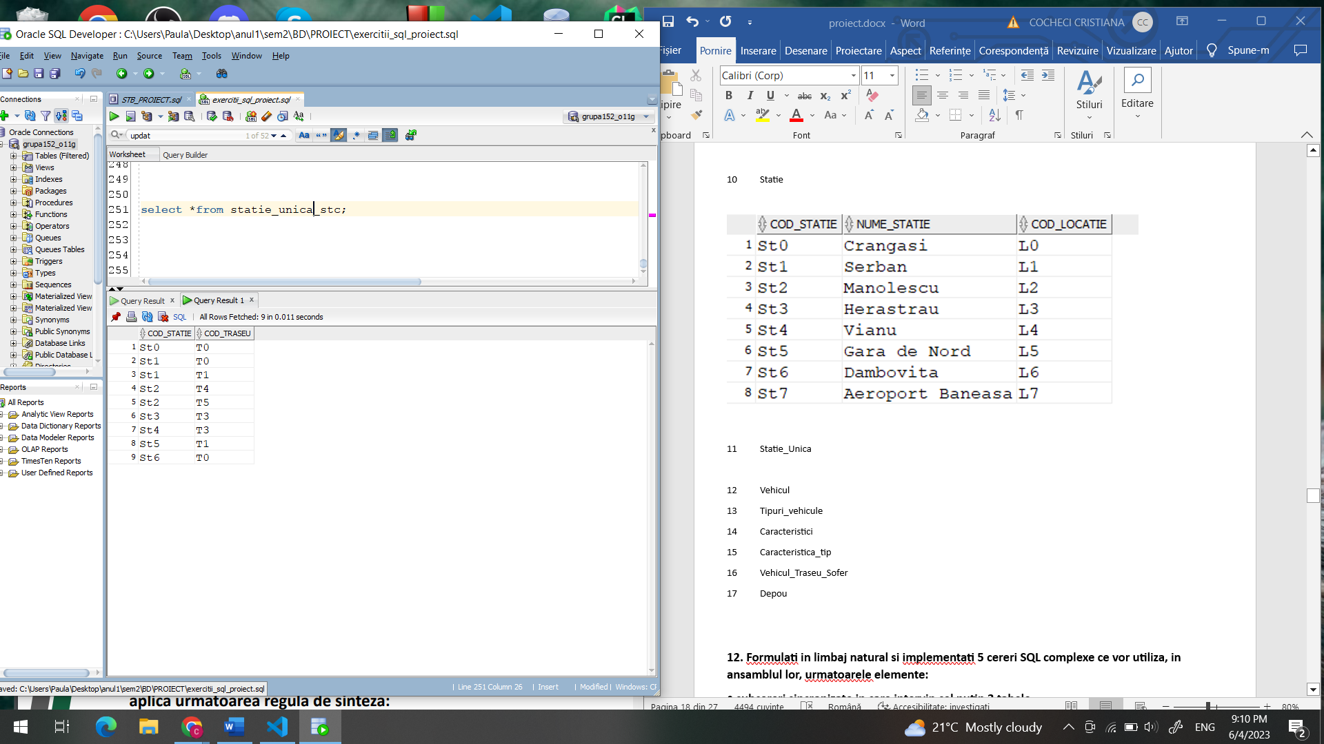

12 Vehicul

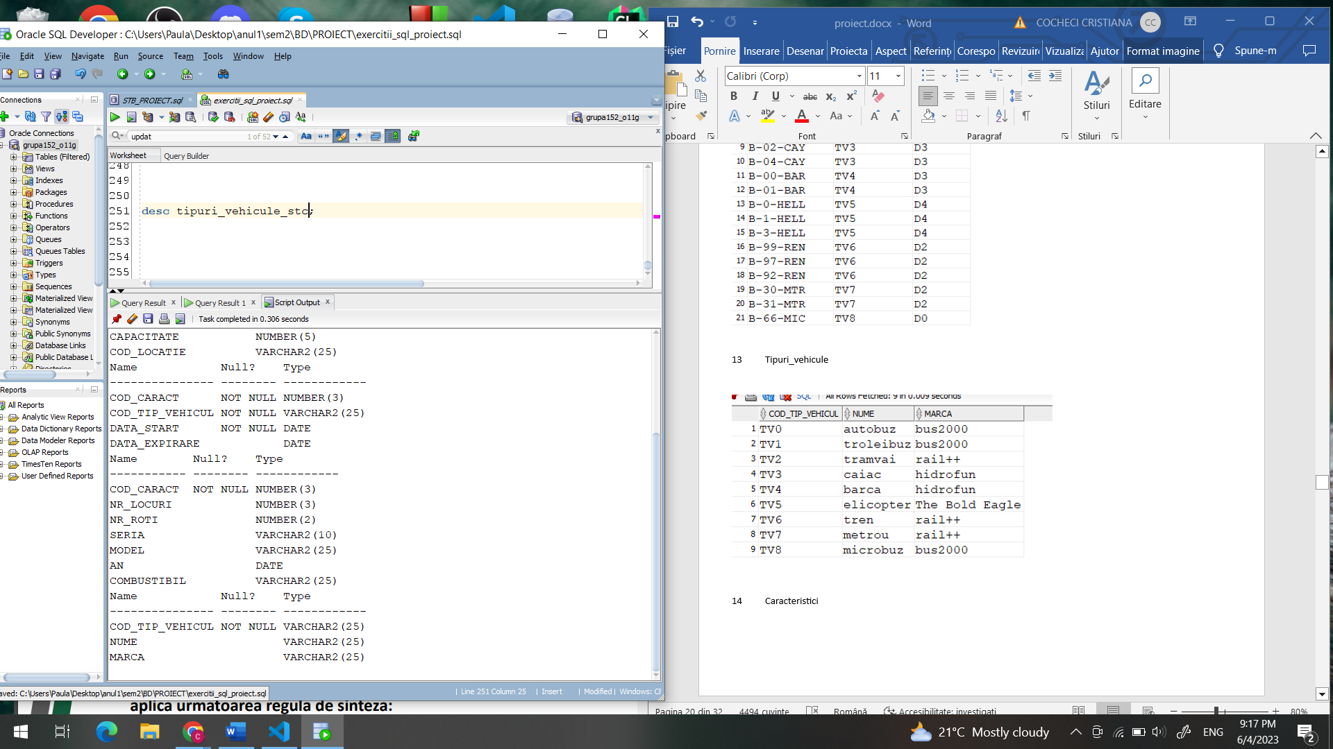

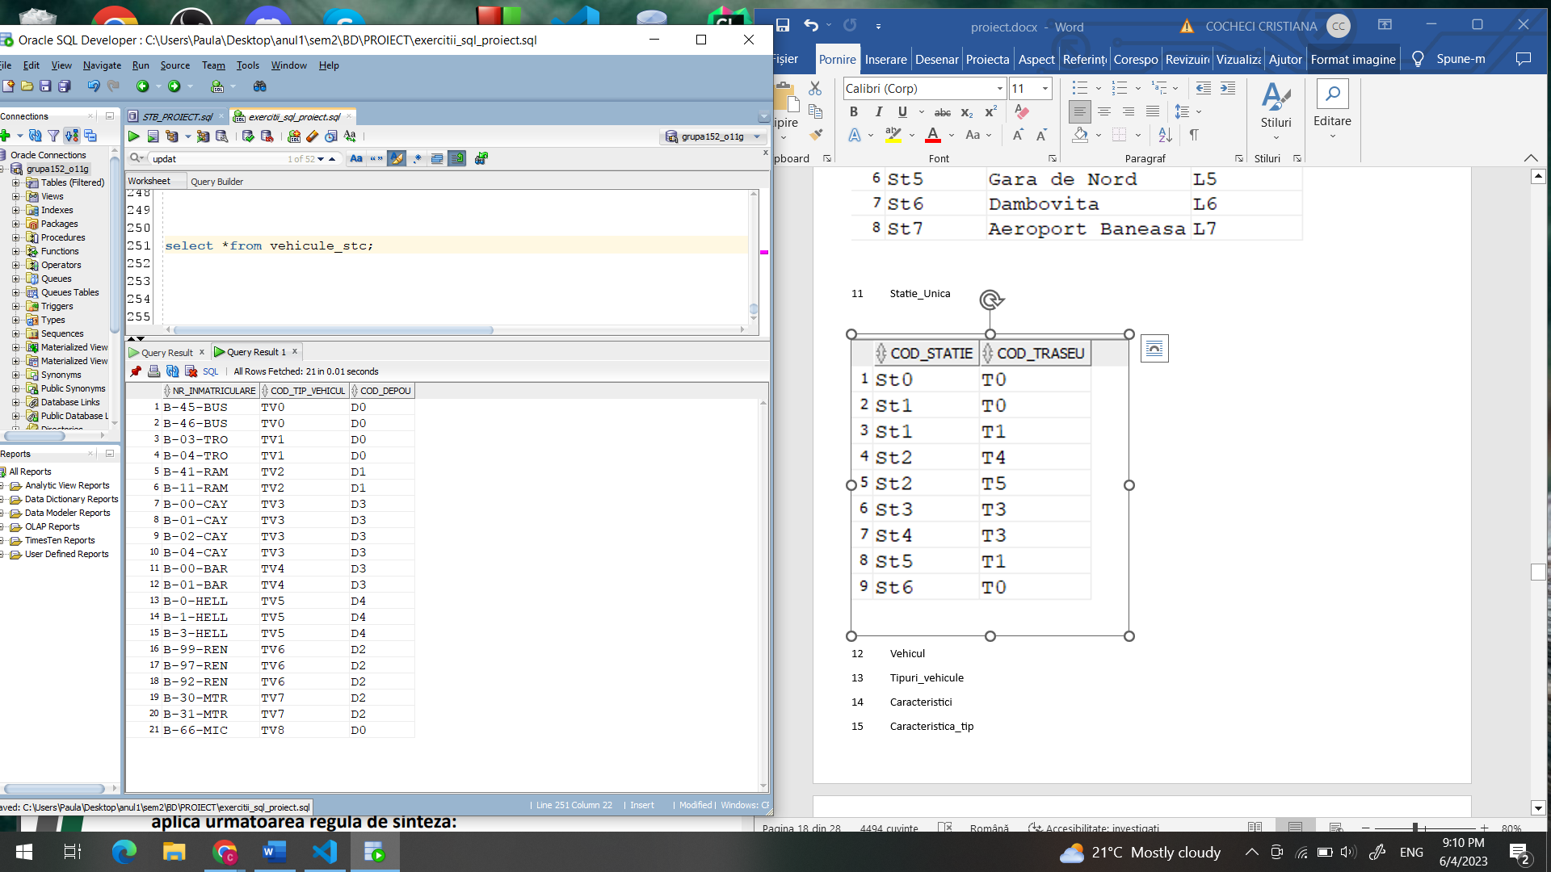

13 Tipuri_vehicule



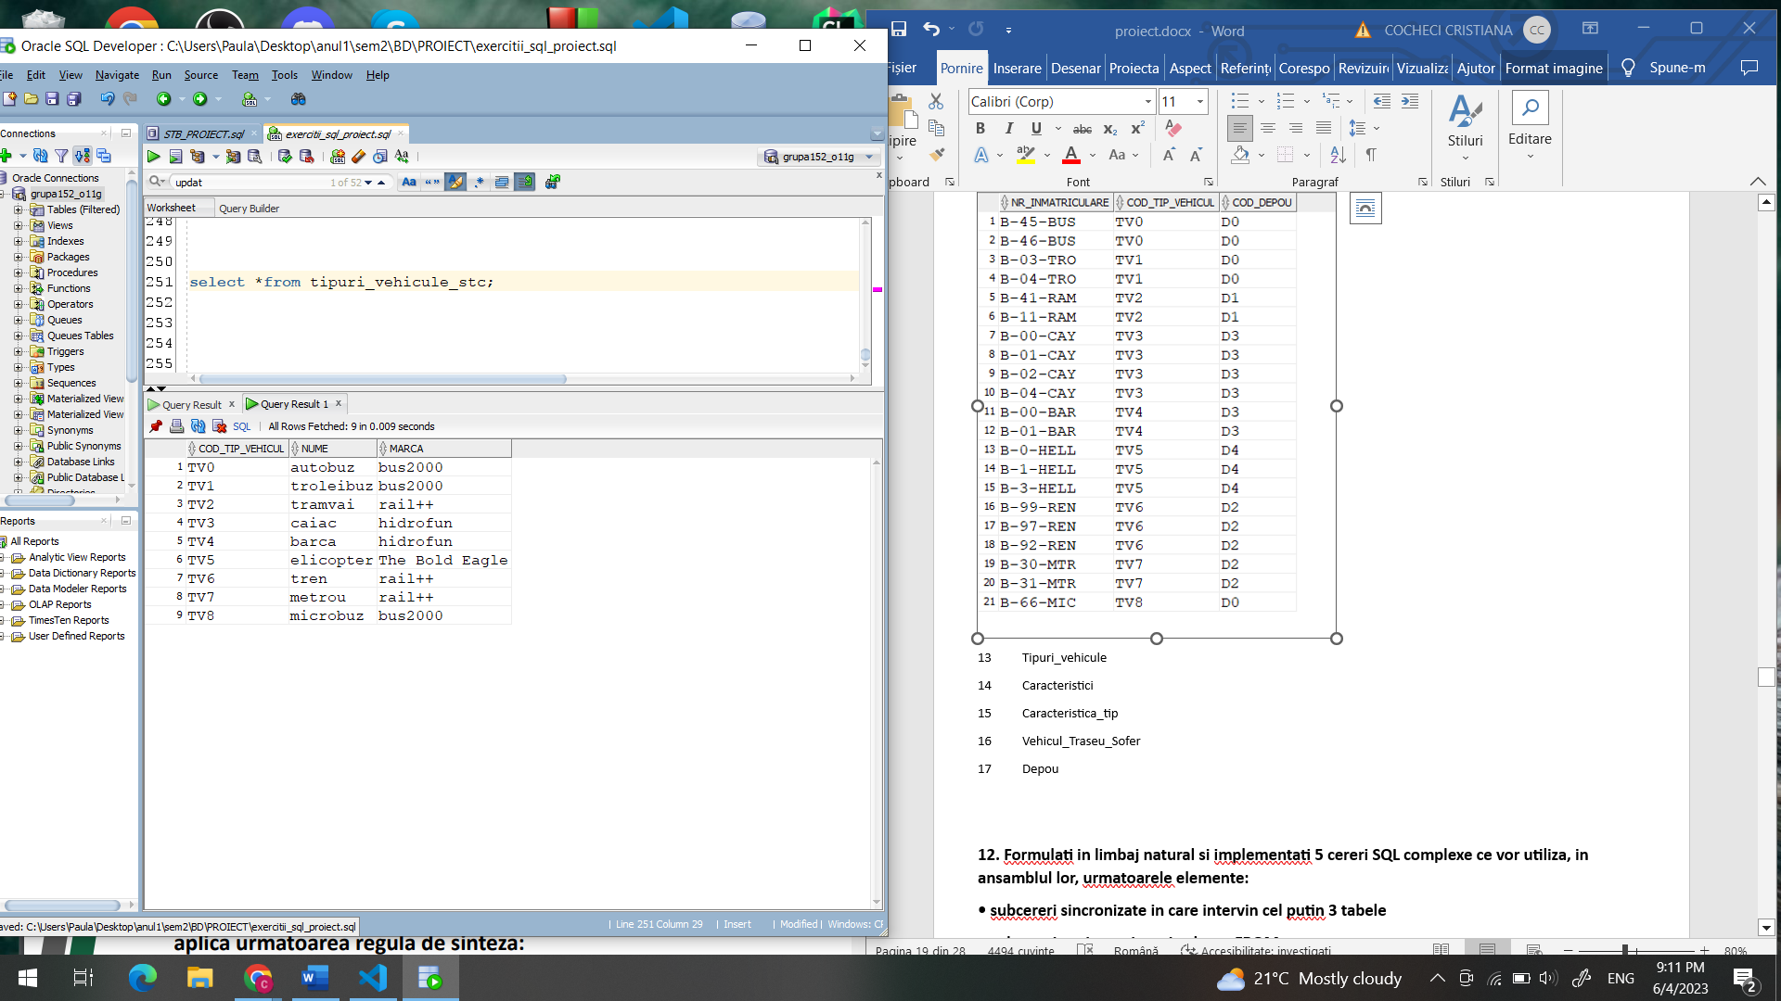

14 Caracteristici

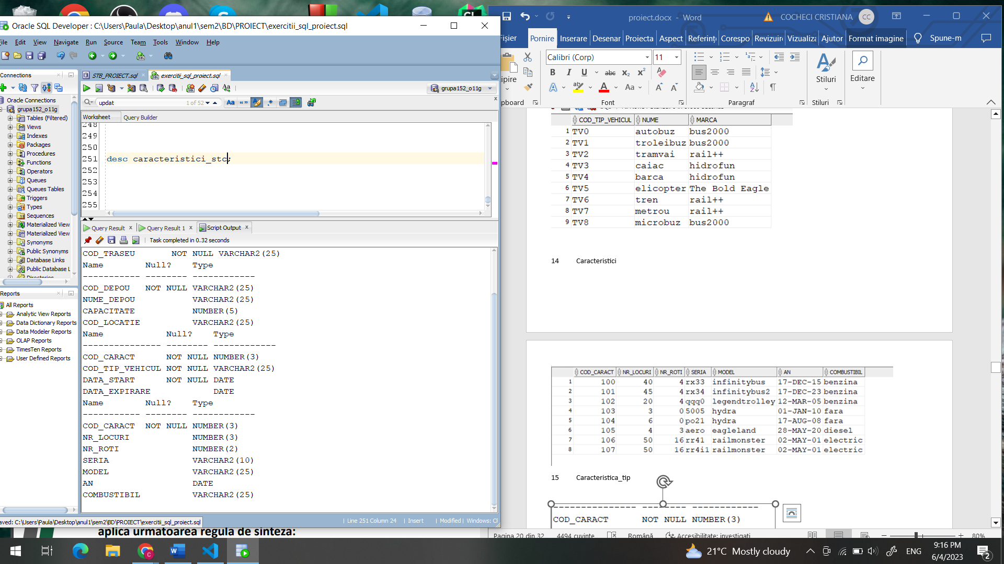

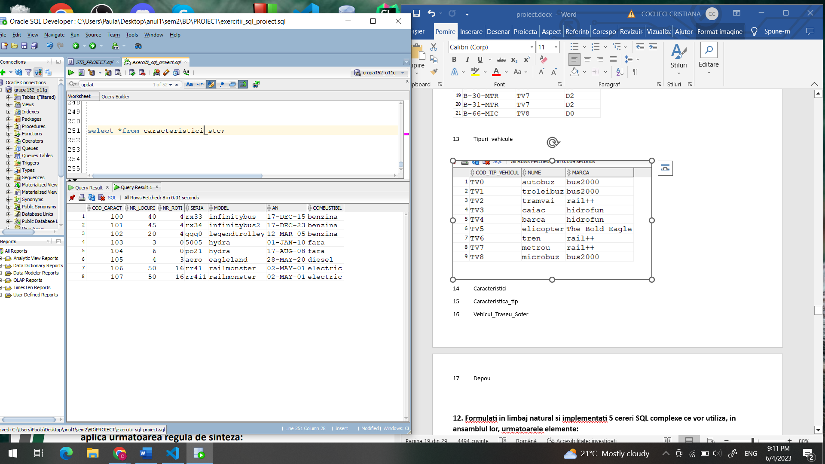

15 Caracteristica_tip

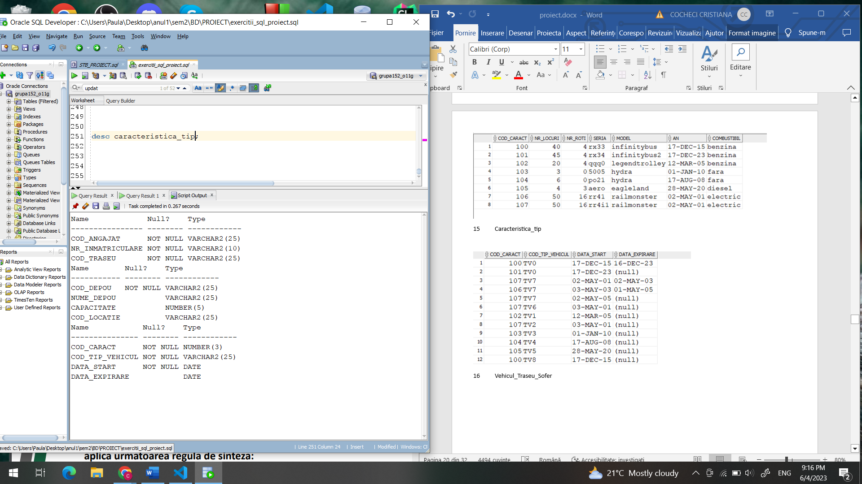

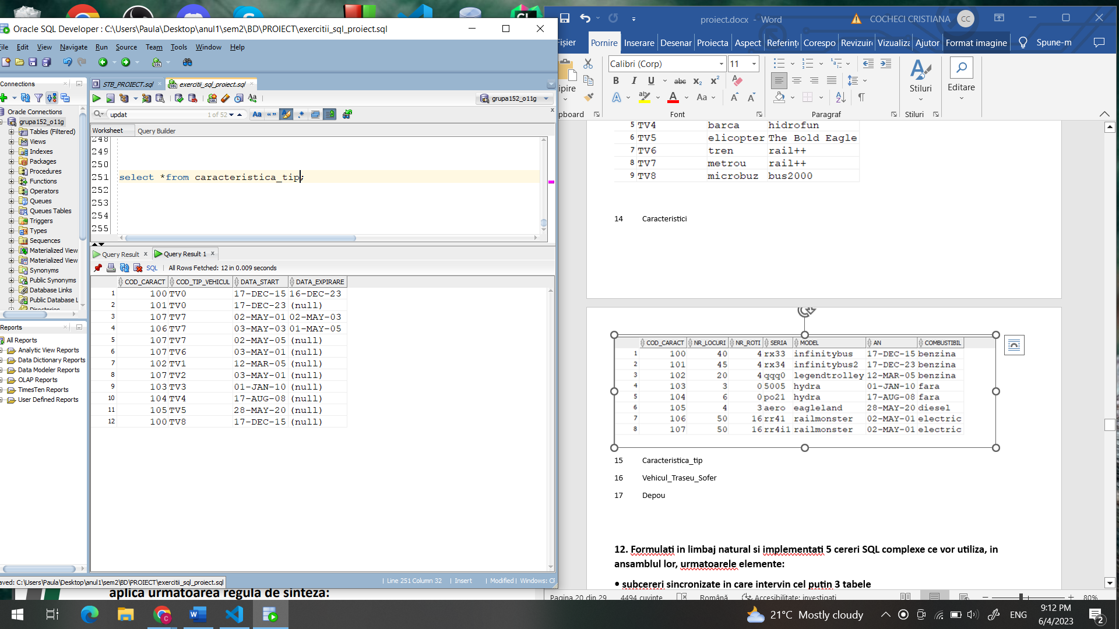

16 Vehicul_Traseu_Sofer

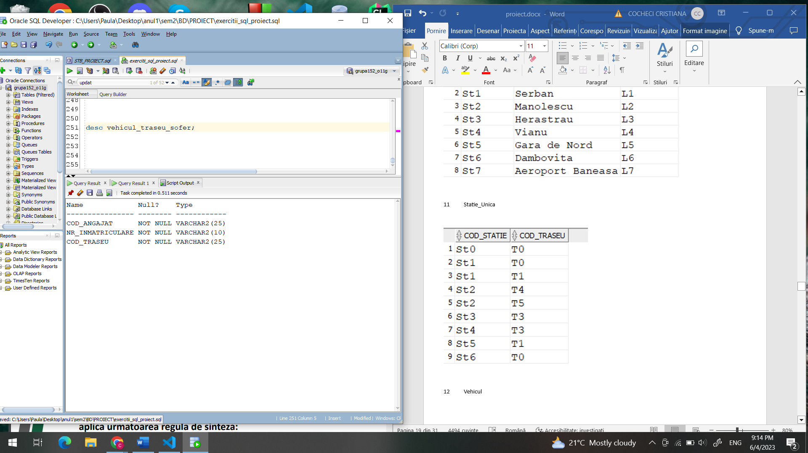

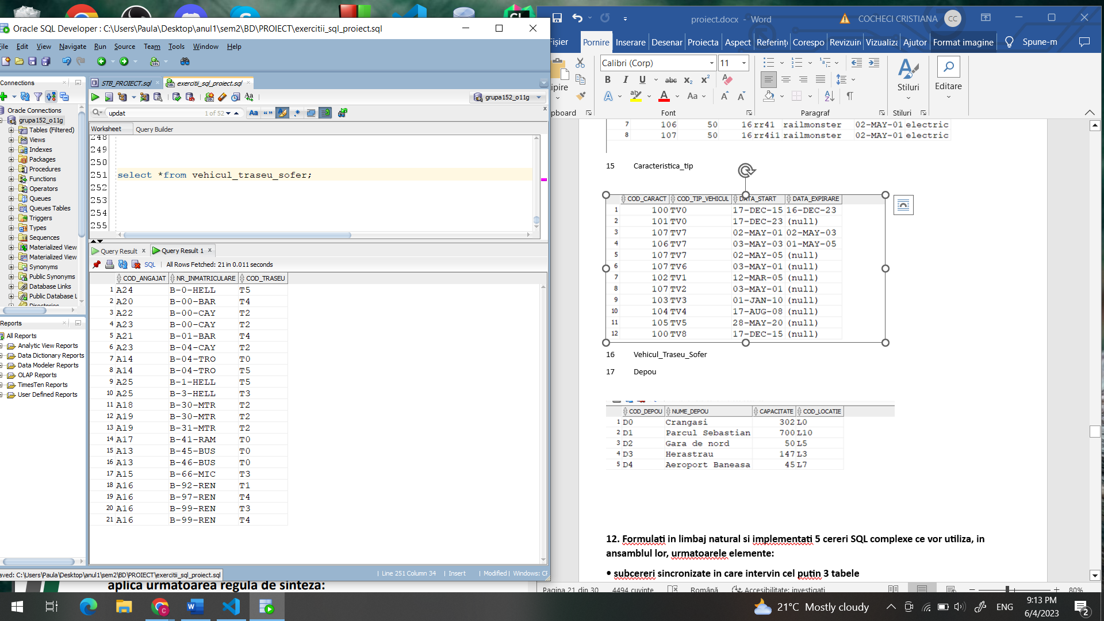

17 Depou

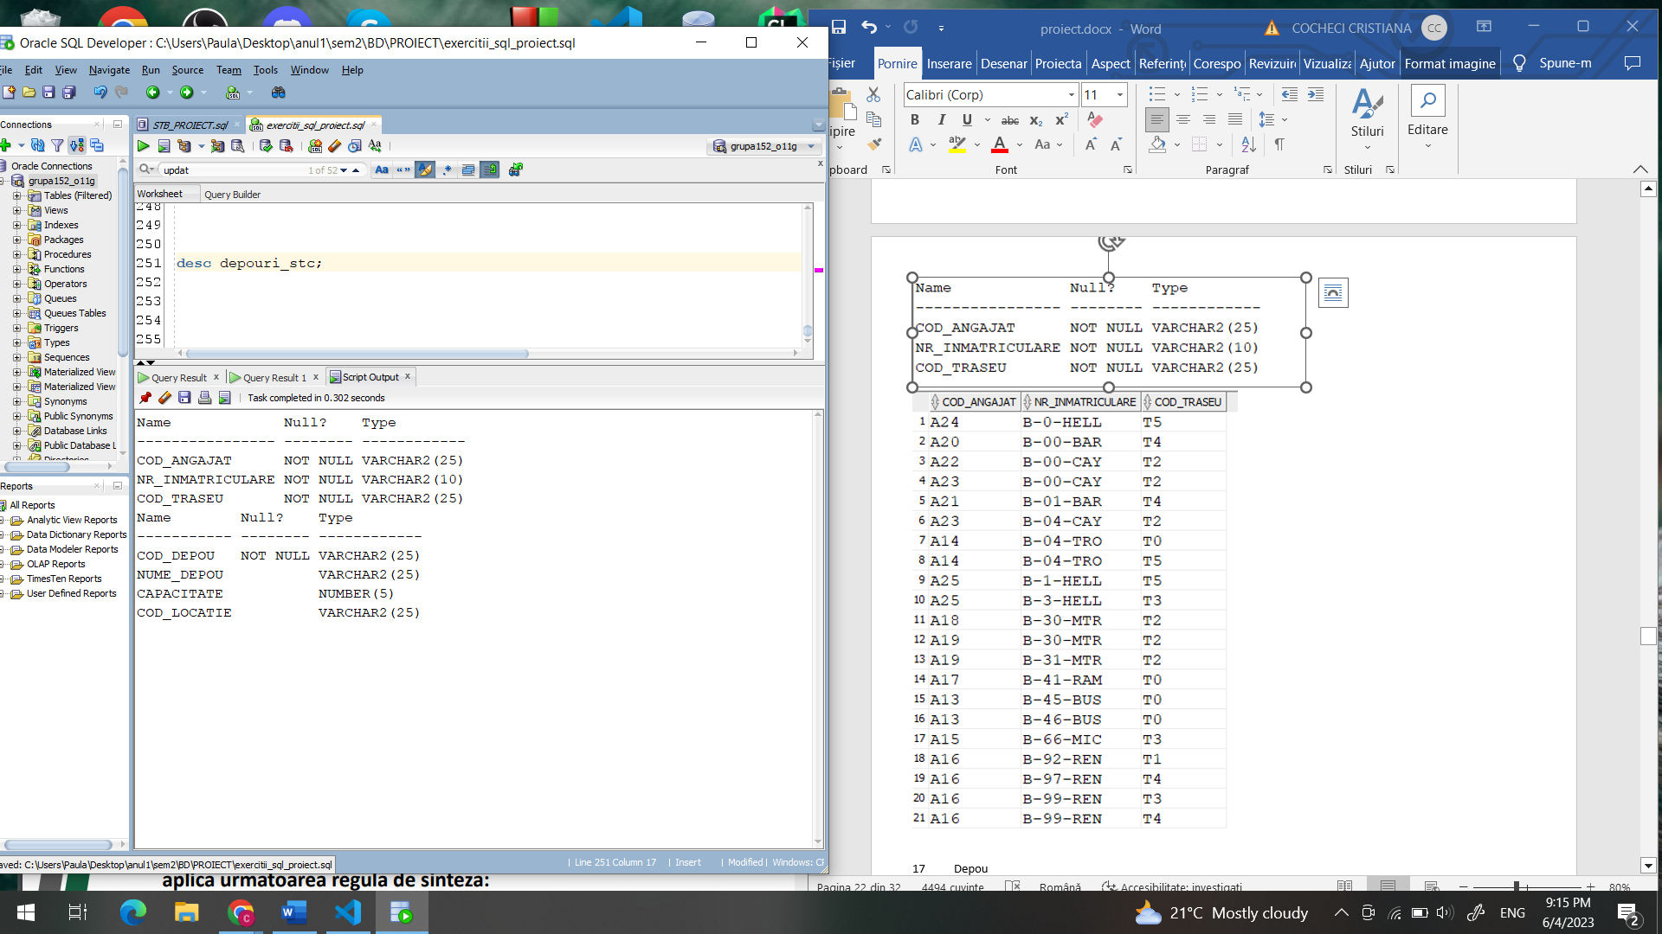

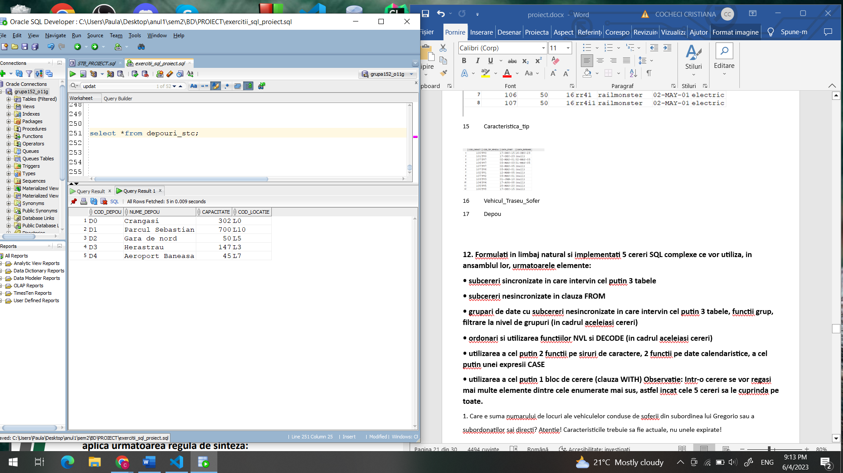

## 6. Colectii

**Formulați în limbaj natural o problemă pe care să o rezolvați folosind un subprogram stocat** **independent care să utilizeze toate cele 3 tipuri de colecții studiate. Apelați subprogramul.**

Sa se afiseze prin intermediul unui subprogram stocat toti angajatii care sunt soferi si conduc cel putin x vehicule, precum si vehiculele respective si traseul pe care sunt conduse, unde x este un parametru de intrare al procedurii.

|  |
| --- |
| CREATE OR REPLACE PROCEDURE colectii_ex_proiect (v_numar NUMBER)  AS  --procedura afla un tablou_indexat al angajatilor cu cel putin 3 vehicule  TYPE record_nr_traseu IS RECORD  (nr_inmatriculare vehicul_traseu_sofer.nr_inmatriculare%TYPE,  traseu vehicul_traseu_sofer.cod_traseu%TYPE);    TYPE tablou_imbricat IS TABLE OF record_nr_traseu;  TYPE tablou_indexat IS TABLE OF tablou_imbricat  INDEX BY angajati_stc.cod_angajat%TYPE;  TYPE vector IS VARRAY(26) OF angajati_stc.cod_angajat%TYPE; --numar de angajati din baza de date  ang vector:=vector(26);  ang_vehicule_indx tablou_indexat;  recs tablou_imbricat;  angajat angajati_stc.cod_angajat%TYPE;  exceptie EXCEPTION;  BEGIN  SELECT cod_angajat  BULK COLLECT INTO ang  FROM angajati_stc;    FOR i IN 1..ang.COUNT LOOP  recs:= tablou_imbricat();  SELECT nr_inmatriculare, cod_traseu  BULK COLLECT INTO recs  FROM vehicul_traseu_sofer  WHERE cod_angajat = ang(i);    IF recs.count >=v_numar THEN  ang_vehicule_indx(ang(i)) := recs;  END IF;  END LOOP;    IF ang_vehicule_indx.COUNT = 0 THEN  raise exceptie;  END IF;  angajat:= ang_vehicule_indx.FIRST;  WHILE angajat != ang_vehicule_indx.LAST LOOP  DBMS_OUTPUT.PUT_LINE('Cod Angajat: ' || angajat);  FOR j IN ang_vehicule_indx(angajat).FIRST .. ang_vehicule_indx(angajat).LAST LOOP  DBMS_OUTPUT.PUT_LINE(' Vehicul: ' || ang_vehicule_indx(angajat)(j).nr_inmatriculare || ', Traseu: ' ||ang_vehicule_indx(angajat)(j).traseu );  END LOOP;  angajat := ang_vehicule_indx.NEXT (angajat);  END LOOP;  DBMS_OUTPUT.PUT_LINE('Cod Angajat: ' || angajat);  FOR j IN ang_vehicule_indx(angajat).FIRST .. ang_vehicule_indx(angajat).LAST LOOP  DBMS_OUTPUT.PUT_LINE(' Vehicul: ' || ang_vehicule_indx(angajat)(j).nr_inmatriculare || ', Traseu: ' ||ang_vehicule_indx(angajat)(j).traseu );  END LOOP;  EXCEPTION  WHEN exceptie THEN  DBMS_OUTPUT.PUT_LINE('Nu exista astfel de angajati');  END colectii_ex_proiect;  /  BEGIN  colectii_ex_proiect(3);  colectii_ex_proiect(5);  END;  / |

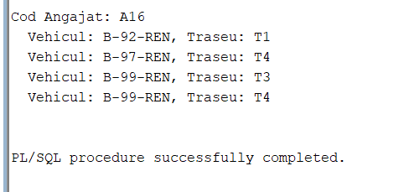

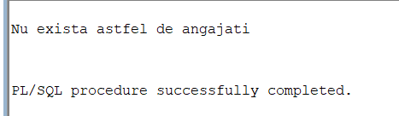

## 7. Cursoare

**Formulați în limbaj natural o problemă pe care să o rezolvați folosind un subprogram stocat** **independent care să utilizeze 2 tipuri diferite de cursoare studiate, unul dintre acestea fiind cursor parametrizat, dependent de celălalt cursor. Apelați subprogramul.**

Calculati lungimea tuturor traseelor care trec prin fiecare statie frecventata de subordonatii directi ai unui angajat dat de la tastatura (lui Dyonis). Sa se trateze exceptiile legate de datele de intrare. Sa se afiseze si statiile respective.

|  |
| --- |
| CREATE OR REPLACE FUNCTION exista_angajat(v_nume_ang angajati_stc.nume%TYPE) RETURN BOOLEAN  AS v_cnt NUMBER;  BEGIN  SELECT count(*) INTO v_cnt  FROM ANGAJATI_STC  WHERE upper(nume) = upper(v_nume_ang);    IF v_cnt > 0 THEN RETURN TRUE;  ELSE RETURN FALSE;  END IF;  END;  /  declare  v_a BOOLEAN;  begin  v_a:=exista_angajat('Dionys');  DBMS_OUTPUT.PUT_LINE(sys.diutil.bool_to_int(v_a));  end;  /  CREATE OR REPLACE PROCEDURE proiect_lungime_trasee  (v_nume_ang IN angajati_stc.nume%TYPE)  AS  TYPE cursor2 IS REF CURSOR;  c2 cursor2;  CURSOR c1 (v_subordonati angajati_stc.cod_angajat%TYPE) IS  (select distinct s.cod_statie, nume_statie, s.cod_traseu  from vehicul_traseu_sofer vts join trasee_stc t on (vts.cod_traseu= t.cod_traseu)  join statie_unica_stc s on (s.cod_traseu= t.cod_traseu)  join angajati_stc a on (vts.cod_angajat= a.cod_angajat)  join statii_stc st on (st.cod_statie = s.cod_statie)  where a.cod_angajat =v_subordonati);    statie statie_unica_stc.cod_statie%TYPE;  nume_statie statii_stc.nume_statie%TYPE;  cod_traseu trasee_stc.cod_traseu%TYPE;    subo angajati_stc.cod_angajat%TYPE;  cod_sef angajati_stc.cod_angajat%TYPE;  lungime_trasee NUMBER;  ok BOOLEAN;  exceptie_ang EXCEPTION;  BEGIN  ok:=exista_angajat(v_nume_ang);  IF ok=FALSE then raise exceptie_ang; END IF;    SELECT cod_angajat INTO cod_sef  FROM ANGAJATI_STC  WHERE upper(nume) = upper(v_nume_ang);  OPEN c2 FOR  'SELECT cod_angajat  FROM ANGAJATI_STC  WHERE cod_sef = :v_cod_sef'  USING cod_sef;    LOOP  FETCH c2 INTO subo;  EXIT WHEN c2%NOTFOUND;  DBMS_OUTPUT.PUT_LINE('Angajatul: '|| subo);  OPEN c1(subo);  LOOP  FETCH c1 INTO statie, nume_statie, cod_traseu;  EXIT WHEN c1%NOTFOUND;  DBMS_OUTPUT.PUT_LINE('Statia: ' || statie ||' '||nume_statie|| ', din traseul: ' ||cod_traseu);  END LOOP;  IF c1%ROWCOUNT=0 THEN  DBMS_OUTPUT.PUT_LINE('Acest angajat nu conduce pe niciun traseu');  ELSE  SELECT sum(lungime) INTO lungime_trasee  FROM trasee_stc WHERE cod_traseu IN  (  select distinct s.cod_traseu  from vehicul_traseu_sofer vts join trasee_stc t on (vts.cod_traseu= t.cod_traseu)  join statie_unica_stc s on (s.cod_traseu= t.cod_traseu)  join angajati_stc a on (vts.cod_angajat= a.cod_angajat)  join statii_stc st on (st.cod_statie = s.cod_statie)  where a.cod_angajat =subo  );    DBMS_OUTPUT.PUT_LINE('Suma lungimilor traseelor parcurse de acest angajat este: ' || lungime_trasee);  END IF;  CLOSE c1;  END LOOP;  IF c2%ROWCOUNT=0 THEN  DBMS_OUTPUT.PUT_LINE('Nu am gasit niciun subordonat al lui' || v_nume_ang);  END IF;  CLOSE c2;  EXCEPTION  WHEN exceptie_ang THEN  DBMS_OUTPUT.PUT_LINE('Nu am gasit angajat cu numele ' || v_nume_ang);  WHEN too_many_rows THEN  DBMS_OUTPUT.PUT_LINE('Prea multi angajati cu numele ' || v_nume_ang);  END;  DECLARE  v_nume angajati_stc.nume%TYPE;  cod_sef angajati_stc.cod_angajat%TYPE;  BEGIN  v_nume :='Dionys';  proiect_lungime_trasee(v_nume);  END;  / |

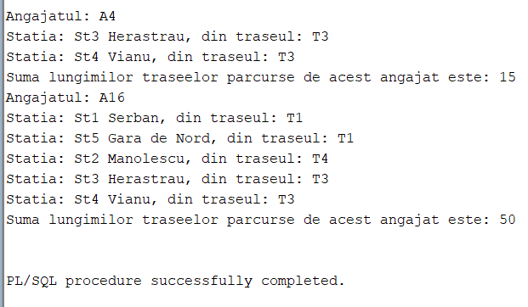

/

## 8. Functie + exceptii proprii

**Formulați în limbaj natural o problemă pe care să o rezolvați folosind un subprogram stocat** **independent de tip funcție care să utilizeze într-o singură comandă SQL 3 dintre tabelele definite.Definiți minim 2 excepții proprii. Apelați subprogramul astfel încât să evidențiați toate cazurile definite și tratate.**

Pentru o sectie data sa se afle toate locatiile filialelor acesteia. Sa se returneze codurile postale ale locatiilor intr-un string.

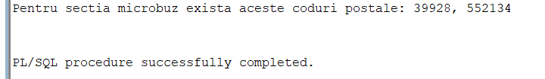

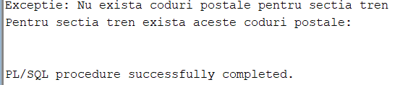

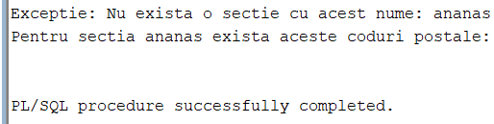

|  |
| --- |
| CREATE OR REPLACE FUNCTION functie_proiect_coduri_postale  (v_sectie sectii_stc.nume_sectie%TYPE DEFAULT 'autobuz')  RETURN VARCHAR2 AS  coduri_postale VARCHAR2(1000);  niciunCod EXCEPTION;  sectieGresita EXCEPTION;  v_count NUMBER;  BEGIN  SELECT COUNT(*)  INTO v_count  FROM sectii_stc  WHERE lower(nume_sectie) = lower(v_sectie);  IF v_count = 0 THEN  RAISE sectieGresita;  END IF;  FOR coduri IN  (SELECT distinct cod_postal  FROM locatii_stc l join filiale_stc f on (l.cod_locatie = f.cod_locatie)  join sectii_stc s on (s.cod_sectie = f.cod_sectie)  WHERE lower(v_sectie) = lower(nume_sectie)) LOOP  coduri_postale := coduri_postale || coduri.cod_postal || ', ';  END LOOP;  IF coduri_postale IS NOT NULL THEN  coduri_postale := RTRIM(coduri_postale, ', ');  ELSE  RAISE niciunCod;  END IF;  RETURN coduri_postale;    EXCEPTION  WHEN sectieGresita THEN  DBMS_OUTPUT.PUT_LINE('Exceptie: Nu exista o sectie cu acest nume: ' || v_sectie);  RETURN NULL;  WHEN niciunCod THEN  DBMS_OUTPUT.PUT_LINE('Exceptie: Nu exista coduri postale pentru sectia ' || v_sectie);  RETURN NULL;  WHEN too_many_rows THEN  DBMS_OUTPUT.PUT_LINE('Exceptie: Prea multe sectii cu numele ' || v_sectie);  RETURN NULL;  END functie_proiect_coduri_postale;    /  DECLARE  CoduriLocatii VARCHAR2(1000);  v_sectie Varchar2(20);  BEGIN  v_sectie :='ananas';  CoduriLocatii := functie_proiect_coduri_postale(v_sectie);    DBMS_OUTPUT.PUT_LINE('Pentru sectia ' || v_sectie || ' exista aceste coduri postale: ' || CoduriLocatii);  END;  / |

## 9. 5 tabele

**Formulați în limbaj natural o problemă pe care să o rezolvați folosind un subprogram stocat** **independent de tip procedură care să utilizeze într-o singură comandă SQL 5 dintre tabelele** **definite. Tratați toate excepțiile care pot apărea, incluzând excepțiile NO_DATA_FOUND și** **TOO_MANY_ROWS. Apelați subprogramul astfel încât să evidențiați toate cazurile tratate.**

Pentru fiecare departament de transport sa se afiseze angajatii sai, daca sunt sau nu soferi si numarul total de roti ale vehiculelor pe care le conduc in prezent

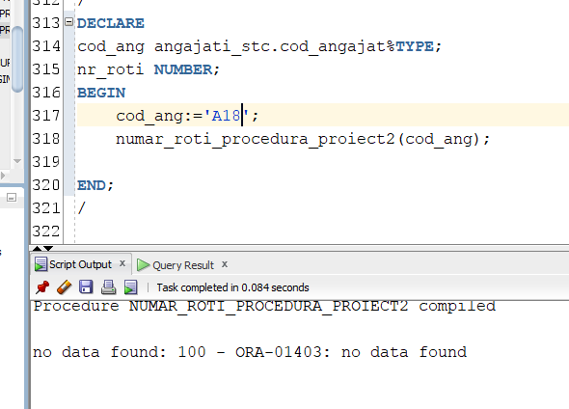

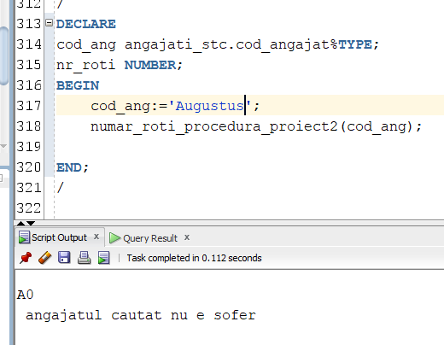

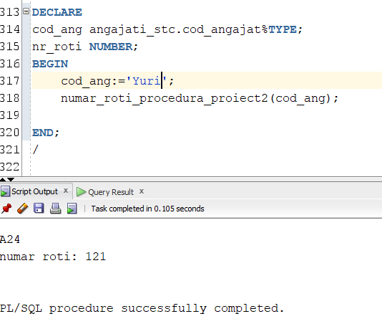

|  |
| --- |
| CREATE OR REPLACE FUNCTION este_sofer (v_cod_ang angajati_stc.cod_angajat%TYPE)  RETURN VARCHAR2 AS rez NUMBER;  BEGIN  SELECT count(*) INTO rez  FROM sofer_stc  WHERE cod_angajat = v_cod_ang;  IF rez = 0 THEN  RETURN 'nu';  else  RETURN 'da';  END IF;  END este_sofer;  /  CREATE OR REPLACE PROCEDURE numar_roti_procedura_proiect2 (nume_angajat angajati_stc.nume%TYPE)  AS    cod_angajat angajati_stc.cod_angajat%TYPE;  numar_roti NUMBER;  v_sofer VARCHAR2(2);  nu_e_sofer EXCEPTION;  BEGIN    SELECT cod_angajat INTO cod_angajat  FROM angajati_stc  WHERE upper(nume) = upper(nume_angajat);    v_sofer := este_sofer(cod_angajat);  DBMS_OUTPUT.PUT_LINE(cod_angajat);  IF v_sofer = 'nu' THEN RAISE nu_e_sofer; END IF;    select sum(nr_roti) INTO numar_roti  from(  select distinct v.nr_inmatriculare, nr_roti, c.cod_caract, nvl(data_expirare,sysdate+1) exp  from vehicul_traseu_sofer v  join vehicule_stc v2 on (v.nr_inmatriculare= v2.nr_inmatriculare)  join tipuri_vehicule_stc tv on (v2.cod_tip_vehicul=tv.cod_tip_vehicul)  join caracteristica_tip c on (tv.cod_tip_vehicul=c.cod_tip_vehicul)  join caracteristici_stc car on (car.cod_caract=c.cod_caract)  where nvl(data_expirare,sysdate+1)>sysdate --verificam ca inca conduce acest vehicul  AND cod_angajat = cod_angajat  );  DBMS_OUTPUT.PUT_LINE('numar roti: ' || numar_roti);  EXCEPTION  WHEN NO_DATA_FOUND THEN  DBMS_OUTPUT.PUT_LINE (' no data found: ' ||SQLCODE || ' - ' || SQLERRM);  WHEN TOO_MANY_ROWS THEN  DBMS_OUTPUT.PUT_LINE (' too many rows: ' ||SQLCODE || ' - ' || SQLERRM);  WHEN nu_e_sofer THEN  DBMS_OUTPUT.PUT_LINE (' angajatul cautat nu e sofer ' );  END numar_roti_procedura_proiect2;  / |

## 10. Definiți un trigger de tip LMD la nivel de comandă. Declanșați trigger-ul.

Triggerul nu permite inserturi sau updateuri pe tabelul sectii_stc in zilele impare ale lunilor pare.

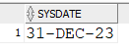

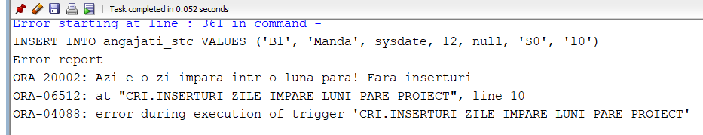

|  |
| --- |
| CREATE OR REPLACE TRIGGER inserturi_zile_impare_luni_pare_proiect  BEFORE INSERT OR UPDATE ON sectii_stc  DECLARE  v_zi NUMBER;  v_luna NUMBER;  BEGIN  SELECT EXTRACT(DAY from SYSDATE), EXTRACT(MONTH from SYSDATE)  INTO v_zi, v_luna  FROM dual;    IF MOD(v_zi, 2) = 1 AND MOD(v_luna, 2) = 0 THEN  RAISE_APPLICATION_ERROR (-20002, 'Azi e o zi impara intr-o luna para! Fara inserturi');  END IF;  END inserturi_zile_impare_luni_pare_proiect;  /  select * from angajati_stc;  INSERT INTO angajati_stc VALUES ('B1', 'Manda', sysdate, 12, null, 'S0', 'l0'); |

## 11. Definiți un trigger de tip LMD la nivel de linie. Declanșați trigger-ul.

Definiti trigger care nu te lasa sa stergi un vehicul care nu e expirat (are data_expirare = null).

|  |
| --- |
| /  CREATE OR REPLACE TRIGGER trigger_proiect_vehicule  BEFORE DELETE ON vehicule_stc  FOR EACH ROW  DECLARE  data_expirare caracteristica_tip.data_expirare%type;  BEGIN  SELECT min(nvl(data_expirare, TO_DATE('1-1-1','DD-MM-YYYY'))) INTO data_expirare  FROM caracteristica_tip  WHERE cod_tip_vehicul = :OLD.cod_tip_vehicul;    IF data_expirare = TO_DATE('1-1-1','DD-MM-YYYY') THEN  RAISE_APPLICATION_ERROR(-20002,'vehiculul nu poate fi sters');  END IF;  END;  /  DELETE FROM vehicule_stc  WHERE cod_tip_vehicul = 'TV6';  / |

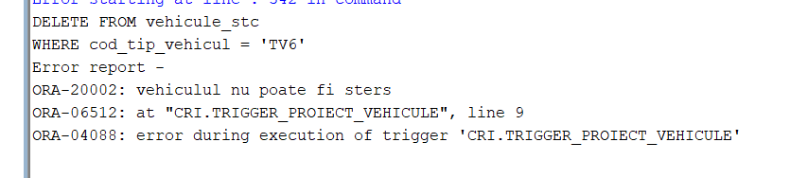

## 12. Definiți un trigger de tip LDD. Declanșați trigger-ul.

Triggerul insereaza intr-un tabel de logging fiecare actiune facuta in baza de date.

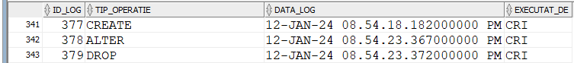

|  |
| --- |
| CREATE SEQUENCE log_sequence  START WITH 1  MAXVALUE 99999999999999999999999999  INCREMENT BY 1  NOCACHE  NOCYCLE;  CREATE TABLE tabel_log_proiect(  id_log NUMBER DEFAULT log_sequence.NEXTVAL PRIMARY KEY,  tip_operatie VARCHAR2(10),  data_log TIMESTAMP default SYSTIMESTAMP,  executat_de VARCHAR2(100)  );  ALTER TABLE tabel_log_proiect  MODIFY tip_operatie VARCHAR2(100);  /  CREATE OR REPLACE TRIGGER trigger_log_LDD  AFTER CREATE OR ALTER OR DROP ON DATABASE  DECLARE  v_user VARCHAR2(100);  BEGIN  SELECT USER INTO v_user FROM dual;  INSERT INTO tabel_log_proiect (tip_operatie, executat_de)  VALUES (SYS.SYSEVENT, v_user);  END;  /  CREaTE TABLE testt (testt NUMBER DEFAULT 0);  drop table testt;  select * from tabel_log_proiect;  / |

**Cerințe opționale pentru nota finală N >= 6:**

13. Pachet

**Definiti un pachet care sa contina toate obiectele definite in cadrup proiectului.**

|  |
| --- |
| CREATE OR REPLACE PACKAGE pachet_proiect_stc AS  PROCEDURE colectii_ex_proiect;  PROCEDURE proiect_lungime_trasee (v_nume_ang IN angajati_stc.nume%TYPE);  FUNCTION functie_proiect_coduri_postale (v_sectie sectii_stc.nume_sectie%TYPE DEFAULT 'autobuz')  RETURN VARCHAR2;  FUNCTION este_sofer (v_cod_ang angajati_stc.cod_angajat%TYPE)  RETURN VARCHAR2;  PROCEDURE numar_roti_procedura_proiect2 (nume_angajat angajati_stc.nume%TYPE);  END pachet_proiect_stc; |
| CREATE OR REPLACE PACKAGE BODY pachet_proiect_stc AS  PROCEDURE colectii_ex_proiect  AS  --procedura afla un tablou_indexat al angajatilor cu cel putin 3 vehicule  TYPE record_nr_traseu IS RECORD  (nr_inmatriculare vehicul_traseu_sofer.nr_inmatriculare%TYPE,  traseu vehicul_traseu_sofer.cod_traseu%TYPE);    TYPE tablou_imbricat IS TABLE OF record_nr_traseu;  TYPE tablou_indexat IS TABLE OF tablou_imbricat  INDEX BY angajati_stc.cod_angajat%TYPE;  TYPE vector IS VARRAY(26) OF angajati_stc.cod_angajat%TYPE; --numar de angajati din baza de date  ang vector:=vector(26);  ang_vehicule_indx tablou_indexat;  recs tablou_imbricat;  angajat angajati_stc.cod_angajat%TYPE;  BEGIN  SELECT cod_angajat  BULK COLLECT INTO ang  FROM angajati_stc;    FOR i IN 1..ang.COUNT LOOP  recs:= tablou_imbricat();  SELECT nr_inmatriculare, cod_traseu  BULK COLLECT INTO recs  FROM vehicul_traseu_sofer  WHERE cod_angajat = ang(i);    IF recs.count >=3 THEN  ang_vehicule_indx(ang(i)) := recs;  END IF;    END LOOP;    angajat:= ang_vehicule_indx.FIRST;  WHILE angajat != ang_vehicule_indx.LAST LOOP  DBMS_OUTPUT.PUT_LINE('Cod Angajat: ' || angajat);  FOR j IN ang_vehicule_indx(angajat).FIRST .. ang_vehicule_indx(angajat).LAST LOOP  DBMS_OUTPUT.PUT_LINE(' Vehicul: ' || ang_vehicule_indx(angajat)(j).nr_inmatriculare || ', Traseu: ' ||ang_vehicule_indx(angajat)(j).traseu );  END LOOP;  angajat := ang_vehicule_indx.NEXT (angajat);  END LOOP;  DBMS_OUTPUT.PUT_LINE('Cod Angajat: ' || angajat);  FOR j IN ang_vehicule_indx(angajat).FIRST .. ang_vehicule_indx(angajat).LAST LOOP  DBMS_OUTPUT.PUT_LINE(' Vehicul: ' || ang_vehicule_indx(angajat)(j).nr_inmatriculare || ', Traseu: ' ||ang_vehicule_indx(angajat)(j).traseu );  END LOOP;    END colectii_ex_proiect;  /***********************/  PROCEDURE proiect_lungime_trasee  (v_nume_ang IN angajati_stc.nume%TYPE)  AS  TYPE cursor2 IS REF CURSOR;  c2 cursor2;  CURSOR c1 (v_subordonati angajati_stc.cod_angajat%TYPE) IS  (select distinct s.cod_statie, nume_statie, s.cod_traseu  from vehicul_traseu_sofer vts join trasee_stc t on (vts.cod_traseu= t.cod_traseu)  join statie_unica_stc s on (s.cod_traseu= t.cod_traseu)  join angajati_stc a on (vts.cod_angajat= a.cod_angajat)  join statii_stc st on (st.cod_statie = s.cod_statie)  where a.cod_angajat =v_subordonati);      statie statie_unica_stc.cod_statie%TYPE;  nume_statie statii_stc.nume_statie%TYPE;  cod_traseu trasee_stc.cod_traseu%TYPE;    subo angajati_stc.cod_angajat%TYPE;  cod_sef angajati_stc.cod_angajat%TYPE;  lungime_trasee NUMBER;    BEGIN  SELECT cod_angajat INTO cod_sef  FROM ANGAJATI_STC  WHERE upper(nume) = upper(v_nume_ang);    OPEN c2 FOR  'SELECT cod_angajat  FROM ANGAJATI_STC  WHERE cod_sef = :v_cod_sef'  USING cod_sef;    LOOP  FETCH c2 INTO subo;  EXIT WHEN c2%NOTFOUND;  DBMS_OUTPUT.PUT_LINE('Angajatul: '|| subo);    OPEN c1(subo);  LOOP  FETCH c1 INTO statie, nume_statie, cod_traseu;  EXIT WHEN c1%NOTFOUND;  DBMS_OUTPUT.PUT_LINE('Statia: ' || statie ||' '||nume_statie|| ', din traseul: ' ||cod_traseu);  END LOOP;  IF c1%ROWCOUNT=0 THEN  DBMS_OUTPUT.PUT_LINE('Acest angajat nu conduce pe niciun traseu');  ELSE  SELECT sum(lungime) INTO lungime_trasee  FROM trasee_stc WHERE cod_traseu IN  (  select distinct s.cod_traseu  from vehicul_traseu_sofer vts join trasee_stc t on (vts.cod_traseu= t.cod_traseu)  join statie_unica_stc s on (s.cod_traseu= t.cod_traseu)  join angajati_stc a on (vts.cod_angajat= a.cod_angajat)  join statii_stc st on (st.cod_statie = s.cod_statie)  where a.cod_angajat =subo  );    DBMS_OUTPUT.PUT_LINE('Suma lungimilor traseelor parcurse de acest angajat este: ' || lungime_trasee);  END IF;  CLOSE c1;  END LOOP;  IF c2%ROWCOUNT=0 THEN  DBMS_OUTPUT.PUT_LINE('Nu am gasit niciun subordonat al lui' || v_nume_ang);  END IF;  CLOSE c2;  END proiect_lungime_trasee;  /****************************/  FUNCTION functie_proiect_coduri_postale  (v_sectie sectii_stc.nume_sectie%TYPE DEFAULT 'autobuz')  RETURN VARCHAR2 AS  coduri_postale VARCHAR2(1000);  niciunCod EXCEPTION;  sectieGresita EXCEPTION;  v_count NUMBER;  BEGIN  SELECT COUNT(*)  INTO v_count  FROM sectii_stc  WHERE lower(nume_sectie) = lower(v_sectie);    IF v_count = 0 THEN  RAISE sectieGresita;  END IF;    FOR coduri IN  (SELECT distinct cod_postal  FROM locatii_stc l join filiale_stc f on (l.cod_locatie = f.cod_locatie)  join sectii_stc s on (s.cod_sectie = f.cod_sectie)  WHERE lower(v_sectie) = lower(nume_sectie)) LOOP  coduri_postale := coduri_postale || coduri.cod_postal || ', ';  END LOOP;  IF coduri_postale IS NOT NULL THEN  coduri_postale := RTRIM(coduri_postale, ', ');  ELSE  RAISE niciunCod;  END IF;    RETURN coduri_postale;    EXCEPTION  WHEN sectieGresita THEN  DBMS_OUTPUT.PUT_LINE('Exceptie: Nu exista o sectie cu acest nume: ' || v_sectie);  RETURN NULL;  WHEN niciunCod THEN  DBMS_OUTPUT.PUT_LINE('Exceptie: Nu exista coduri postale pentru sectia ' || v_sectie);  RETURN NULL;    END functie_proiect_coduri_postale;  /****************************************/  FUNCTION este_sofer (v_cod_ang angajati_stc.cod_angajat%TYPE)  RETURN VARCHAR2 AS rez NUMBER;  BEGIN  SELECT count(*) INTO rez  FROM sofer_stc  WHERE cod_angajat = v_cod_ang;  IF rez = 0 THEN  RETURN 'nu';  else  RETURN 'da';  END IF;  END este_sofer;  /**************************/  PROCEDURE numar_roti_procedura_proiect2 (nume_angajat angajati_stc.nume%TYPE)  AS    cod_angajat angajati_stc.cod_angajat%TYPE;  numar_roti NUMBER;  v_sofer VARCHAR2(2);  nu_e_sofer EXCEPTION;  BEGIN    SELECT cod_angajat INTO cod_angajat  FROM angajati_stc  WHERE upper(nume) = upper(nume_angajat);    v_sofer := este_sofer(cod_angajat);  DBMS_OUTPUT.PUT_LINE(cod_angajat);  IF v_sofer = 'nu' THEN RAISE nu_e_sofer; END IF;    select sum(nr_roti) INTO numar_roti  from(  select distinct v.nr_inmatriculare, nr_roti, c.cod_caract, nvl(data_expirare,sysdate+1) exp  from vehicul_traseu_sofer v  join vehicule_stc v2 on (v.nr_inmatriculare= v2.nr_inmatriculare)  join tipuri_vehicule_stc tv on (v2.cod_tip_vehicul=tv.cod_tip_vehicul)  join caracteristica_tip c on (tv.cod_tip_vehicul=c.cod_tip_vehicul)  join caracteristici_stc car on (car.cod_caract=c.cod_caract)  where nvl(data_expirare,sysdate+1)>sysdate --verificam ca inca conduce acest vehicul  AND cod_angajat = cod_angajat  );  DBMS_OUTPUT.PUT_LINE('numar roti: ' || numar_roti);    EXCEPTION  WHEN NO_DATA_FOUND THEN  DBMS_OUTPUT.PUT_LINE (' no data found: ' ||SQLCODE || ' - ' || SQLERRM);  WHEN TOO_MANY_ROWS THEN  DBMS_OUTPUT.PUT_LINE (' too many rows: ' ||SQLCODE || ' - ' || SQLERRM);  WHEN nu_e_sofer THEN  DBMS_OUTPUT.PUT_LINE (' angajatul cautat nu e sofer ' );  END numar_roti_procedura_proiect2;    /************************************/  END pachet_proiect_stc;  /  DECLARE  v_nume angajati_stc.nume%TYPE;  cod_sef angajati_stc.cod_angajat%TYPE;  BEGIN  v_nume :='Dionys';  pachet_proiect_stc.proiect_lungime_trasee(v_nume);  END;  /*etc, functioneaza la fel ca mai sus, mai trebuie doar adaugat inaintea functiilor si procelurilor numele pachetului*/  / |
|  |

## 14. Pachet complex

**Definiți un pachet care să includă tipuri de date complexe și obiecte necesare unui flux de acțiuni integrate, specifice bazei de date definite (minim 2 tipuri de date, minim 2 funcții, minim 2 proceduri).**

Sa se creeze unul/ mai multi triggeri care nu permite ca suma salariului in

sectii cu mai putin de 3 locatii sau cu locatia L0 sa fie 20000

Sa se afiseze datele inainte de modificare.

In implementare sa se foloseasca un pachet complex care retine date despre salarii, precum si locatii ale sectiilor.

|  |
| --- |
| CREATE OR REPLACE PACKAGE pachet_proiect_complex_stc AS  TYPE lista_LOCATII IS TABLE OF locatii_stc.cod_locatie%TYPE;    TYPE record_sectii_locatii IS RECORD (sal angajati_stc.salariu%type, lista_loc lista_LOCATII);  TYPE t_indexat_sectii IS TABLE OF angajati_stc.salariu%type  INDEX BY angajati_stc.cod_sectie%TYPE;  sectii_salariu t_indexat_sectii;  salariu_sum angajati_stc.salariu%type;  TYPE t_indexat_sectii_record IS TABLE OF record_sectii_locatii  INDEX BY angajati_stc.cod_sectie%TYPE;  PROCEDURE tabel_record;  tabel t_indexat_sectii_record;  FUNCTION sal_sum_pt_sectie (cod_sectie angajati_stc.cod_sectie%TYPE)  RETURN angajati_stc.salariu%type;  PROCEDURE afisare_date_sal_sum;  PROCEDURE initializare_sal_sum;  CURSOR cursor_sectii IS (select cod_sectie from sectii_stc);  CURSOR cursor_locatii_per_sectie(v_sectie angajati_stc.cod_sectie%TYPE)  IS (SELECT cod_locatie FROM angajati_stc WHERE cod_sectie= v_sectie);  FUNCTION exista_l(l lista_LOCATII, v locatii_stc.cod_locatie%TYPE) RETURN BOOLEAN;  END pachet_proiect_complex_stc;  /  CREATE OR REPLACE PACKAGE BODY pachet_proiect_complex_stc AS  FUNCTION exista_l(l lista_LOCATII, v locatii_stc.cod_locatie%TYPE) RETURN BOOLEAN  AS b BOOLEAN;  BEGIN  b:=false;  FOR i in 1..l.last LOOP  IF l(i) = v THEN b:=true; END IF;  END LOOP;  RETURN b;  END;  PROCEDURE tabel_record  AS  rec record_sectii_locatii;  v_cod sectii_stc.cod_sectie%TYPE;    BEGIN  initializare_sal_sum;  OPEN cursor_sectii;  LOOP  FETCH cursor_sectii INTO v_cod;  EXIT WHEN cursor_sectii%NOTFOUND;  rec.sal:=sectii_salariu(v_cod);    SELECT distinct nvl(cod_locatie,'no') BULK COLLECT INTO rec.lista_loc  FROM angajati_stc WHERE cod_sectie = v_cod AND cod_locatie IS NOT NULL;    tabel(v_cod):=rec;    END LOOP;  CLOSE cursor_sectii;  END tabel_record;  PROCEDURE afisare_date_sal_sum  AS  sectie angajati_stc.cod_sectie%TYPE;  cnt Number;  exceptie EXCEPTION;  nr_sectii NUMBER;  BEGIN  cnt := sectii_salariu.COUNT;  SELECT count(*) INTO nr_sectii from sectii_stc;  IF cnt <nr_sectii THEN  raise exceptie;  END IF;  sectie := sectii_salariu.FIRST;  WHILE sectie!= sectii_salariu.LAST LOOP  DBMS_OUTPUT.PUT_LINE('Sectia ' || sectie || ' are suma salariilor: '|| sectii_salariu(sectie));  sectie:= sectii_salariu.NEXT(sectie);  END LOOP;  DBMS_OUTPUT.PUT_LINE('Sectia ' || sectie || ' are suma salariilor: '|| sectii_salariu(sectie));  EXCEPTION  WHEN exceptie THEN  DBMS_OUTPUT.PUT_LINE ('Nu sunt toate sectiile completate, mai incercati o data.');  initializare_sal_sum;  END afisare_date_sal_sum;  /********************************/  FUNCTION sal_sum_pt_sectie (cod_sectie angajati_stc.cod_sectie%TYPE)  RETURN angajati_stc.salariu%type  AS sal_sum angajati_stc.salariu%type; q VARCHAR2(300);  BEGIN  q := 'SELECT SUM(salariu) FROM angajati_stc ' || 'WHERE cod_sectie = :v_sectie';  EXECUTE IMMEDIATE q  INTO sal_sum  USING cod_sectie;    sectii_salariu(cod_sectie):=sal_sum;  RETURN sal_sum;  END sal_sum_pt_sectie;  /***************************/  PROCEDURE initializare_sal_sum AS  v_cod angajati_stc.cod_sectie%TYPE;  aux angajati_stc.salariu%TYPE;  BEGIN  salariu_sum:=0;  OPEN cursor_sectii;  LOOP  FETCH cursor_sectii INTO v_cod;  EXIT WHEN cursor_sectii%NOTFOUND;  aux:=sal_sum_pt_sectie(v_cod);  salariu_sum:=salariu_sum +aux;  END LOOP;  CLOSE cursor_sectii;  salariu_sum:= salariu_sum;  END initializare_sal_sum;  END pachet_proiect_complex_stc;  /  DECLARE  sec angajati_stc.cod_sectie%TYPE;  rez NUMBER;  tabel_rezultat pachet_proiect_complex_stc.t_indexat_sectii_record;  BEGIN  sec:='S0';  /*rez := pachet_proiect_complex_stc.sal_mediu_pt_sectie(sec);*/    /*DBMS_OUTPUT.PUT_LINE(rez); */  /*pachet_proiect_complex_stc.initializare_sal_mediu;*/  pachet_proiect_complex_stc.afisare_date_sal_sum;  /*tabel_rezultat := pachet_proiect_complex_stc.tabel_record;  DBMS_OUTPUT.PUT_LINE(tabel_rezultat(sec).sal);*/  END;  /  /*sa se creeze unul/ mai multi triggeri care nu permite ca suma salariului in  sectii cu mai putin de 3 locatii sau cu locatia L0 sa fie 9000, si care verifica ca suma totala a  salariilor sa nu fie 9001  Sa se afiseze datele inainte de modificare  */  CREATE OR REPLACE TRIGGER trg_complex_1_stc  BEFORE INSERT OR UPDATE OF salariu ON angajati_stc  DECLARE v sectii_stc.cod_sectie%type;  BEGIN  OPEN pachet_proiect_complex_stc.cursor_sectii;  LOOP  FETCH pachet_proiect_complex_stc.cursor_sectii INTO v;  EXIT WHEN pachet_proiect_complex_stc.cursor_sectii%NOTFOUND;  pachet_proiect_complex_stc.sectii_salariu(v):=0;  END LOOP;  CLOSE pachet_proiect_complex_stc.cursor_sectii;      pachet_proiect_complex_stc.tabel_record;  DBMS_OUTPUT.PUT_LINE('INAINTE----------------');  pachet_proiect_complex_stc.afisare_date_sal_sum;    END;  /  CREATE OR REPLACE TRIGGER trg_complex_2_stc  BEFORE INSERT OR UPDATE OF salariu ON angajati_stc  FOR EACH ROW  DECLARE  b BOOLEAN;  cnt NUMBER;  sec sectii_stc.cod_sectie%TYPE;  BEGIN  sec:= pachet_proiect_complex_stc.tabel.FIRST;    WHILE sec IS NOT NULL LOOP  DBMS_OUTPUT.PUT_LINE('Inside loop for section ' || sec);  IF pachet_proiect_complex_stc.tabel(sec).lista_loc IS NULL THEN  cnt := 0;  ELSE  cnt := pachet_proiect_complex_stc.tabel(sec).lista_loc.COUNT();  END IF;  b:=pachet_proiect_complex_stc.exista_l(pachet_proiect_complex_stc.tabel(sec).lista_loc, 'L0');  IF cnt IS NOT NULL THEN  DBMS_OUTPUT.PUT_LINE(cnt);  ELSE  DBMS_OUTPUT.PUT_LINE('Count is NULL');  END IF;  DBMS_OUTPUT.PUT_LINE(sys.diutil.bool_to_int(b));  IF (cnt<3 OR b = TRUE) AND sec = :OLD.cod_sectie THEN  DBMS_OUTPUT.PUT_LINE('a');  IF pachet_proiect_complex_stc.tabel(sec).sal - :OLD.salariu + :NEW.salariu>20000 THEN  RAISE_APPLICATION_ERROR(-20000,'Sectia '||sec||' depaseste salariul admis.');    null;  END IF;  EXIT;  END IF;  pachet_proiect_complex_stc.sectii_salariu(sec):=pachet_proiect_complex_stc.tabel(sec).sal - :OLD.salariu + :NEW.salariu;  sec:=pachet_proiect_complex_stc.tabel.NEXT(sec);  END LOOP;    END;  /  UPdate angajati_stc SET salariu = 15000 ;  rollback;  commit;  /  select * from angajati_stc; |

